

THE OKLAHOMA PIPELINE ENERGY STORAGE SYSTEM (OPESS) Conceptual Design Report

By Jonathan Grinnell

Fall 2022



EN.645.800

Mentor Robert Krzystan

|  |  |  |
| --- | --- | --- |
| Document Name | Date | Reason for Change |
| Grinnell CDR | 10/5/22 | Initial Document |
| Grinnell CDR_A | 10/21/22 | Revision made per instructors suggestions |

Contents

1 CONCEPTUAL DESIGN Description 5

2 OPESS ConOps 7

2.1 System Need 7

2.2 System Block Diagram 7

2.2.1 OPESS Block Diagram 8

2.2.2 ESS Block Diagram 8

2.2.3 CaCS Block Diagram 9

3 Component Development 11

3.1 OPESS Physical Block Diagram 11

3.2 ESS Block Diagram 12

3.3 CaCS Block Diagram 12

4 Requirement Analysis 14

4.1 System Requirements 14

4.2 Requirement Verification 14

4.3 Key Performance Parameters 15

4.4 Requirements Metric 17

5 Earned Value Management 18

5.1 Schedule 18

5.3 EVM 18

5.4 CPI and SPI Index 19

6 Risk 19

6.1 Risk 1: Weather 20

6.2 Risk 2: Earthquake 20

6.3 Risk 3: Residual Natural Gas 21

6.4 Risk 4: Cyber Security 21

7 References 22

8 Appendix A: Physical Block Diagram 23

9 Appendix B: Component to Requirement Traceability Matrix 66

Table of Figures

Figure 1: OPESS Block Diagram End of TS Version 8

Figure 2:ESS Block Diagram End of TS Version 9

Figure 3: CaCS Block Diagram End of TS Version 10

Figure 4: OPESS Physical Block Diagram 11

Figure 5: ESS Physical Block Diagram 12

Figure 6: CaCS Physical Block Diagram 13

Figure 7: CPI and SPI Index 19

Figure 8: Risk 1 Weather 20

Figure 9: Risk 2 Earthquake 20

Figure 10: Risk 3 Residual Natural Gas 21

Figure 11: Risk 4 Cyber Security 21

Table of Tables

Table 1: MOE Summary 5

Table 2 List of Solution Needs 7

Table 3: Requirement Type 14

Table 4: Verification Method 15

Table 5: : Key Performance Parameters 15

Table 6: KPP Description 15

Table 7: Requirements Metric 17

Table 8: CDR Schedule 18

Table 9: Milestones 18

Table 10: EVM 18

# 1 CONCEPTUAL DESIGN Description

The **CONCEPTUAL DESIGN REPORT (CDR)** will be delivered as the fifth delivery of the **Oklahoma Pipeline Energy Storage System (OPESS)**. This report will be composed of a Concept of Operations as well as an analysis of the physical architecture. Additionally, a requirement analysis will be present in this document. Schedule, EVM and CPI/SPI will also be discussed during this project. The risks first detailed in the OPESS proposal will be updated with any risk reduction efforts that were performed in the functional development phase of the OPESS Project.

The concept of operations will provide a description of the functional need that the OPESS aims to fill. It will focus on spelling out the current makeup of the Oklahoma power grid, its increasing reliance on renewable sources of energy and why a new energy solution will be needed to meet future demand. After that, the ConOps will dive further into the design of the OPESS system through the use of block diagrams in an attempt to flesh out the two subsystems that compose the OPESS.

The physical architecture discussed in this report was developed using block diagrams developed alongside the requirements as well as the functional work developed during the FAR. Requirements were traced to functions as reported in the Functional Analysis report. During the CDR, the functions were assigned to physical components. Since the requirements were already traced to functions, this now allows for full traceability between requirements and the physical architecture.

This document will also provide an update of the EVM as it stands as of this writing. Schedule updates, deliveries, the WBS and SPI/CPI will be discussed in this section

Risks will be the last real section of the CDR. In this section, the risks outlines in the initial proposal will be updated and new risk reduction techniques developed during the requirement development stage will be taken into account.

Lastly, several appendixes will be attached to this document. These appendixes will be a listing of physical architecture, linking and a cross reference matrix. Since this is fairly long winded and not written in a form conducive to a report, it was thought best to keep it in a separate format for reference purposes.

Appendix A contains the totality of physical block diagrams developed as a part of the CDR effort. Appendix B contains a traceability matric connecting the requirements, functions and physical architecture together. This will demonstrate the full tractability from the physical component to the foundational requirements. Appendix C contains the VCRM.

All KPP’s listed in section 3.5 trace to MOE 2 through MOE 4. These MOEs can be found in the table below. These remain unchanged from the RAR.

Table : MOE Summary

| MOE Number | Summary |
| --- | --- |
| MOE 1 | The energy efficiency of the OPESS must be high enough to be of worth to the market. |
| MOE 2 | The ESS must be able to store energy on the time span of months to years. |
| MOE 3 | The OPESS much adhere to proper cyber security standards. |
| MOE 4 | The ESS should be able to stand up to the elements. |
| MOE 5 | The OPESS must not produce carbon emissions. |

MOE 1 was left was not referenced by the KPPs since that particular MOE is really more of a market and financial requirement. This MOE is still an important one to have listed and reference as this requirement will ultimately be what decides the viability of the OPESS system.

# 2 OPESS ConOps

## 2.1 System Need

In 2010 Oklahoma mandated that 15% of the state’s energy needs be provided by some form of renewable energy source. As early as 2012 the state surpassed that goal (Popovich & Plumer, 2020). In 2021, the amount of energy produced by renewable sources accounted for 45% of the state’s energy needs. That number continues to increase as new wind projects are stood up and roof top solar becomes more popular. Unfortunately, wind and solar are not a source of consistent power. When the sun goes down homeowners are forced to either pull power from a grid that still produces energy primarily from dirty sources or from an expensive battery pack. High pressure systems can also move in, causing time periods of low wind energy production or worse yet, strong winds can come in during storm season and produce an excess of wind energy, forcing wind turbines offline.

The solution is to install large amounts of grid level energy storage. This will help even out the peaks and valleys of energy production, allowing energy produces on high energy days to be used on low energy days. Batteries are expensive and will compete with electric cars as their demands rises and pumped hydro can’t really be used in Oklahoma as the state neither gets the required amount of rain or has enough in the way of mountains to make it practical.

What the state does have in abundance are natural gas wells. It is through the use of this resource common to the state that a form of green energy storage can be developed. A list of solution needs can be found is table 2.

Table List of Solution Needs

|  |  |  |
| --- | --- | --- |
| Number | Name | Description |
| 1 | Extra Storage | The OPESS needs to be able to store extra energy from renewable sources during times of over production. |
| 2 | Low-Cost Storage | The OPESS needs to be able to store energy produced on the grid during low rates for use during times of high rates |
| 3 | Long Term Storage | The OPESS needs to be able to store energy for a significant amount of time with minimal loss. This will be measured on the timeframe of months to years. |
| 4 | Grid Scale Storage | The OPESS needs to be able to provide an energy storage solution that can be maintained on a grid level. |

## 2.2 System Block Diagram

The system block diagrams were produced during the RAR. They have been modified a bit as the design of the OPESS has changed though they have remained relatively intact for the most part. The block diagrams can be found in the sections below however, section 3 will contain the new physical block diagrams created for this report.

### 2.2.1 OPESS Block Diagram

The OPESS is composed of two major subsystems. The first is the Energy Storage Subsystem (ESS). The ESS is the actual storage system of the OPESS system. Functionally, it pulls power off the grid, compressed air for storage in spend natural gas wells, and then used that gas to spin a turbine for use on the grid. Since this device is outside, it is exposed to the elements and will thus need to be protected.

The second major subsystem is the Command-and-Control Subsystem (CaCS). As its name suggests, it performs the command-and-control functionality of the OPESS system. The CaCS allows communication between the OPESS and other utility companies and plants that might be powering the grid at the time. The CaCS communicated with the ESS over a secured internet connection.

Figure : OPESS Block Diagram End of TS Version

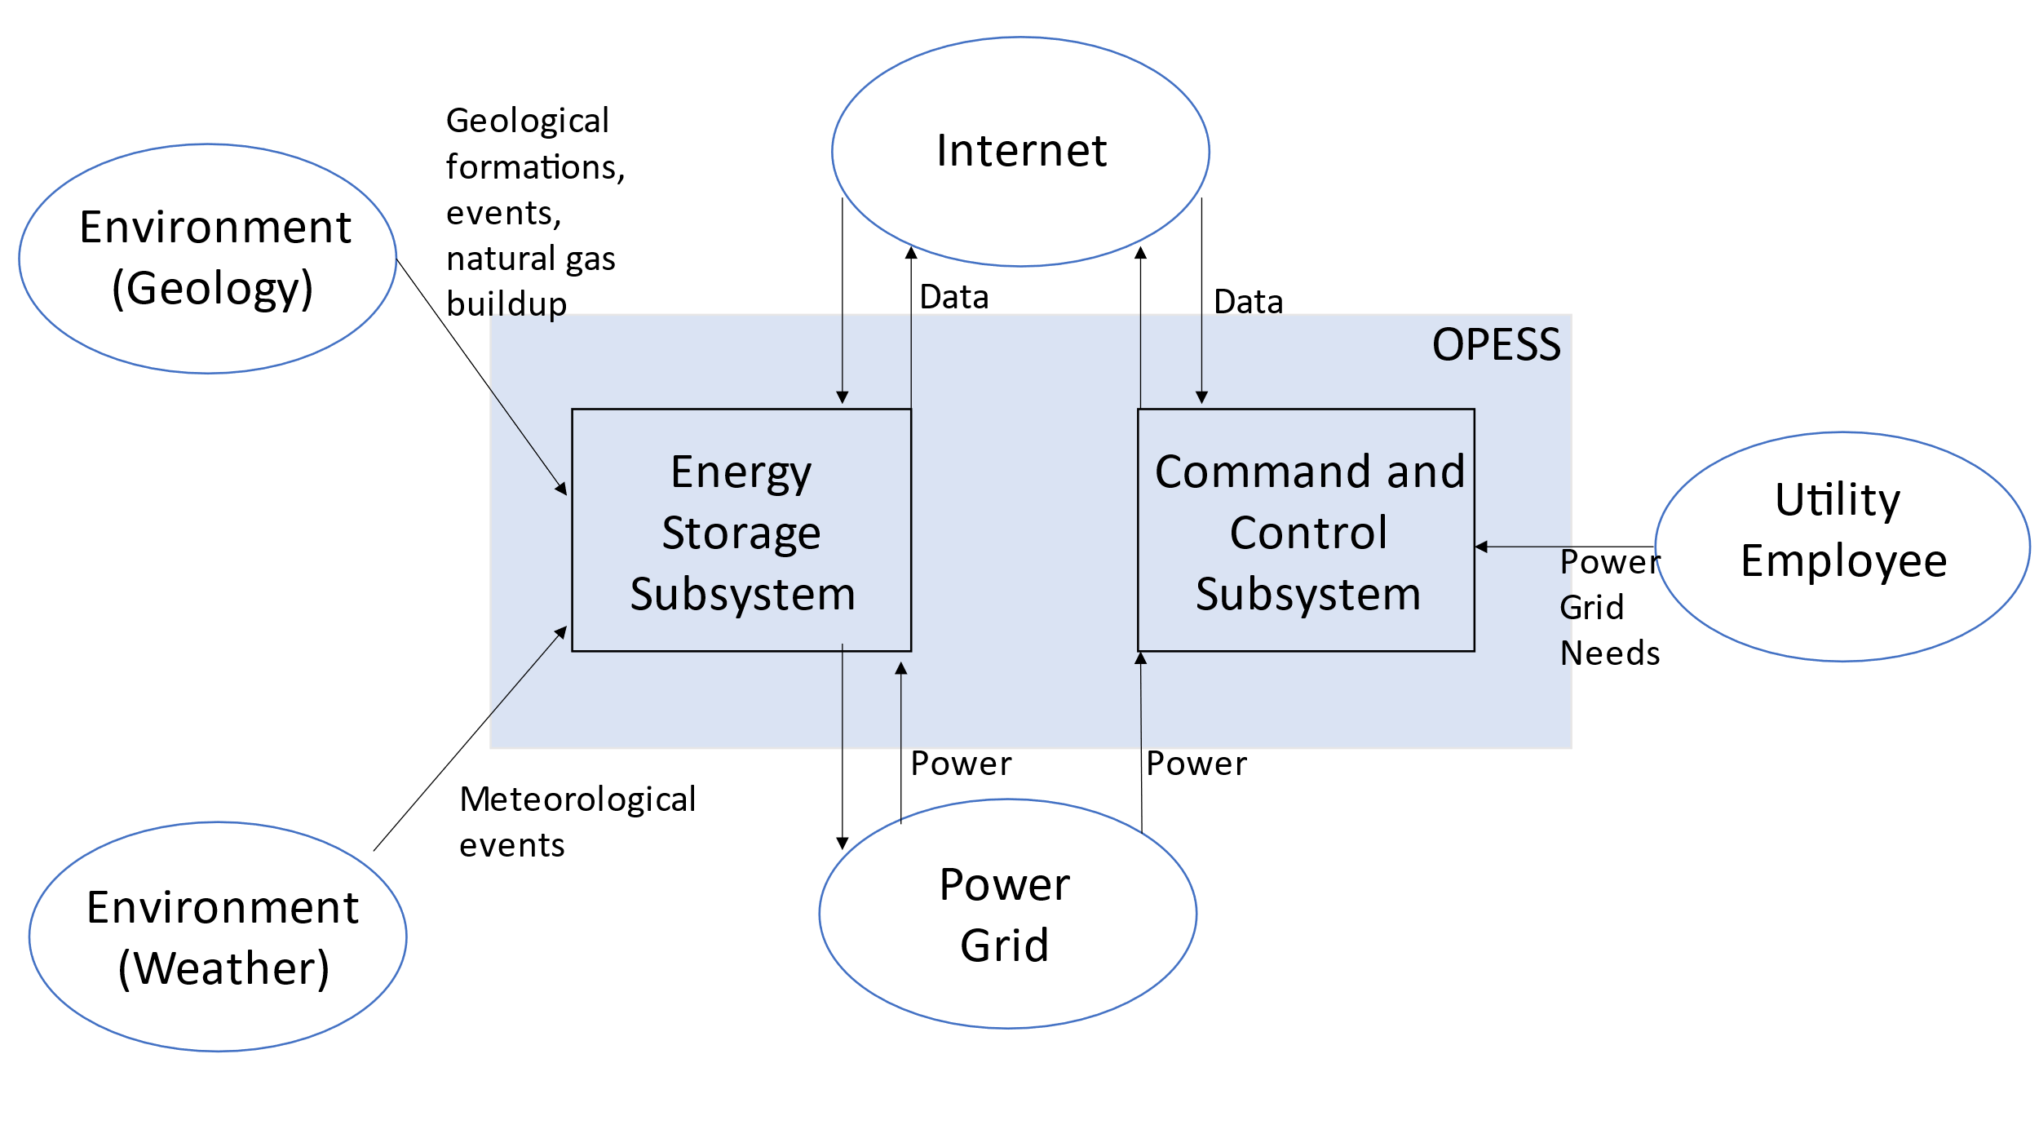

### 2.2.2 ESS Block Diagram

The ESS is the heart of the OPESS. It is composed of 5 functions, receive power, store power, generate power, a control node and weather protection. The primary function of the ESS is to act as a battery, hence the first three functions, however, unlike a batter, this is a complicated piece of equipment with lots of moving parts. A localized control note will have to be included in order to tell the individual components of the ESS how to behave. Additionally, this node will communicate with the CaCS and report and health and status issues the ESS might be experiencing.

Additionally, per risk 1, the ESS will be exposed to the elements on a regular bases and Oklahoma is famous for its bad weather. The final function, weather protection, is a risk reduction function meant to protect the ESS.

Figure :ESS Block Diagram End of TS Version

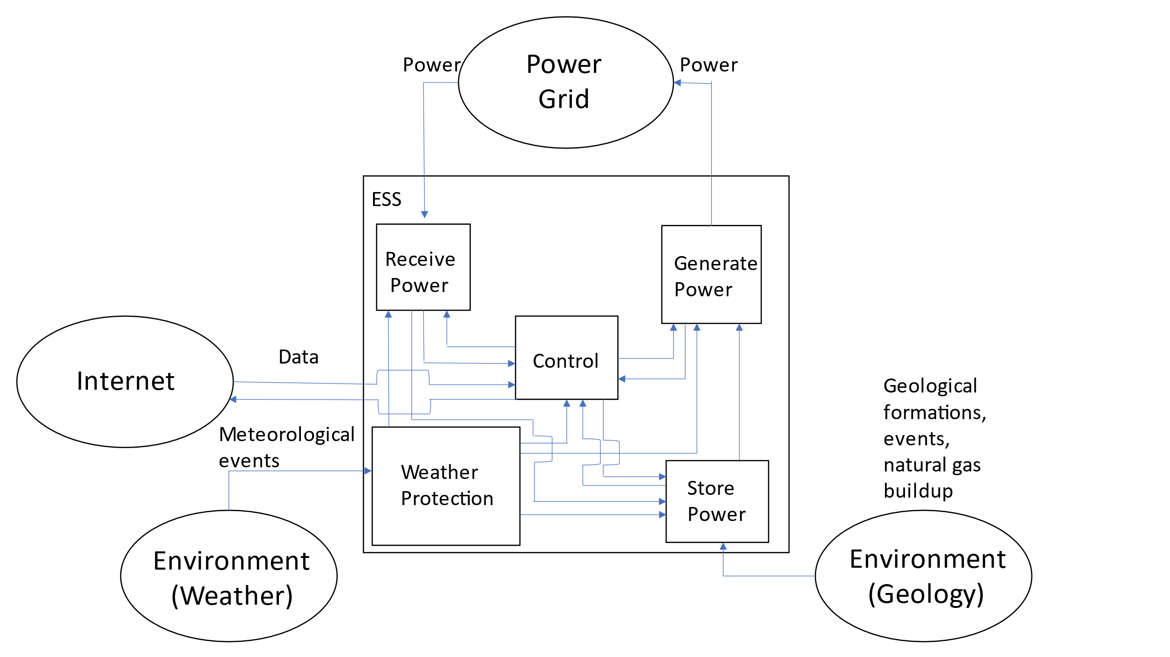

### 2.2.3 CaCS Block Diagram

The CaCS is the brains of the OPESS system. It exists primarily as an office space that allows utility workers, economists and engineers to communicate with other facilities both locally and across state lines in an effort to figure out what the future and current electrical needs will be. The CaCS will be able to allow employees access to modeling software in an effort of predict the future needs of the OPESS system on the grid. The CaCS will also allow employees to log into the ESS from their desk, monitor health and status and even control the ESS without having to go into the field. This will be helpful as issues can be diagnosed and handled without sending out technicians into the field.

Figure : CaCS Block Diagram End of TS Version

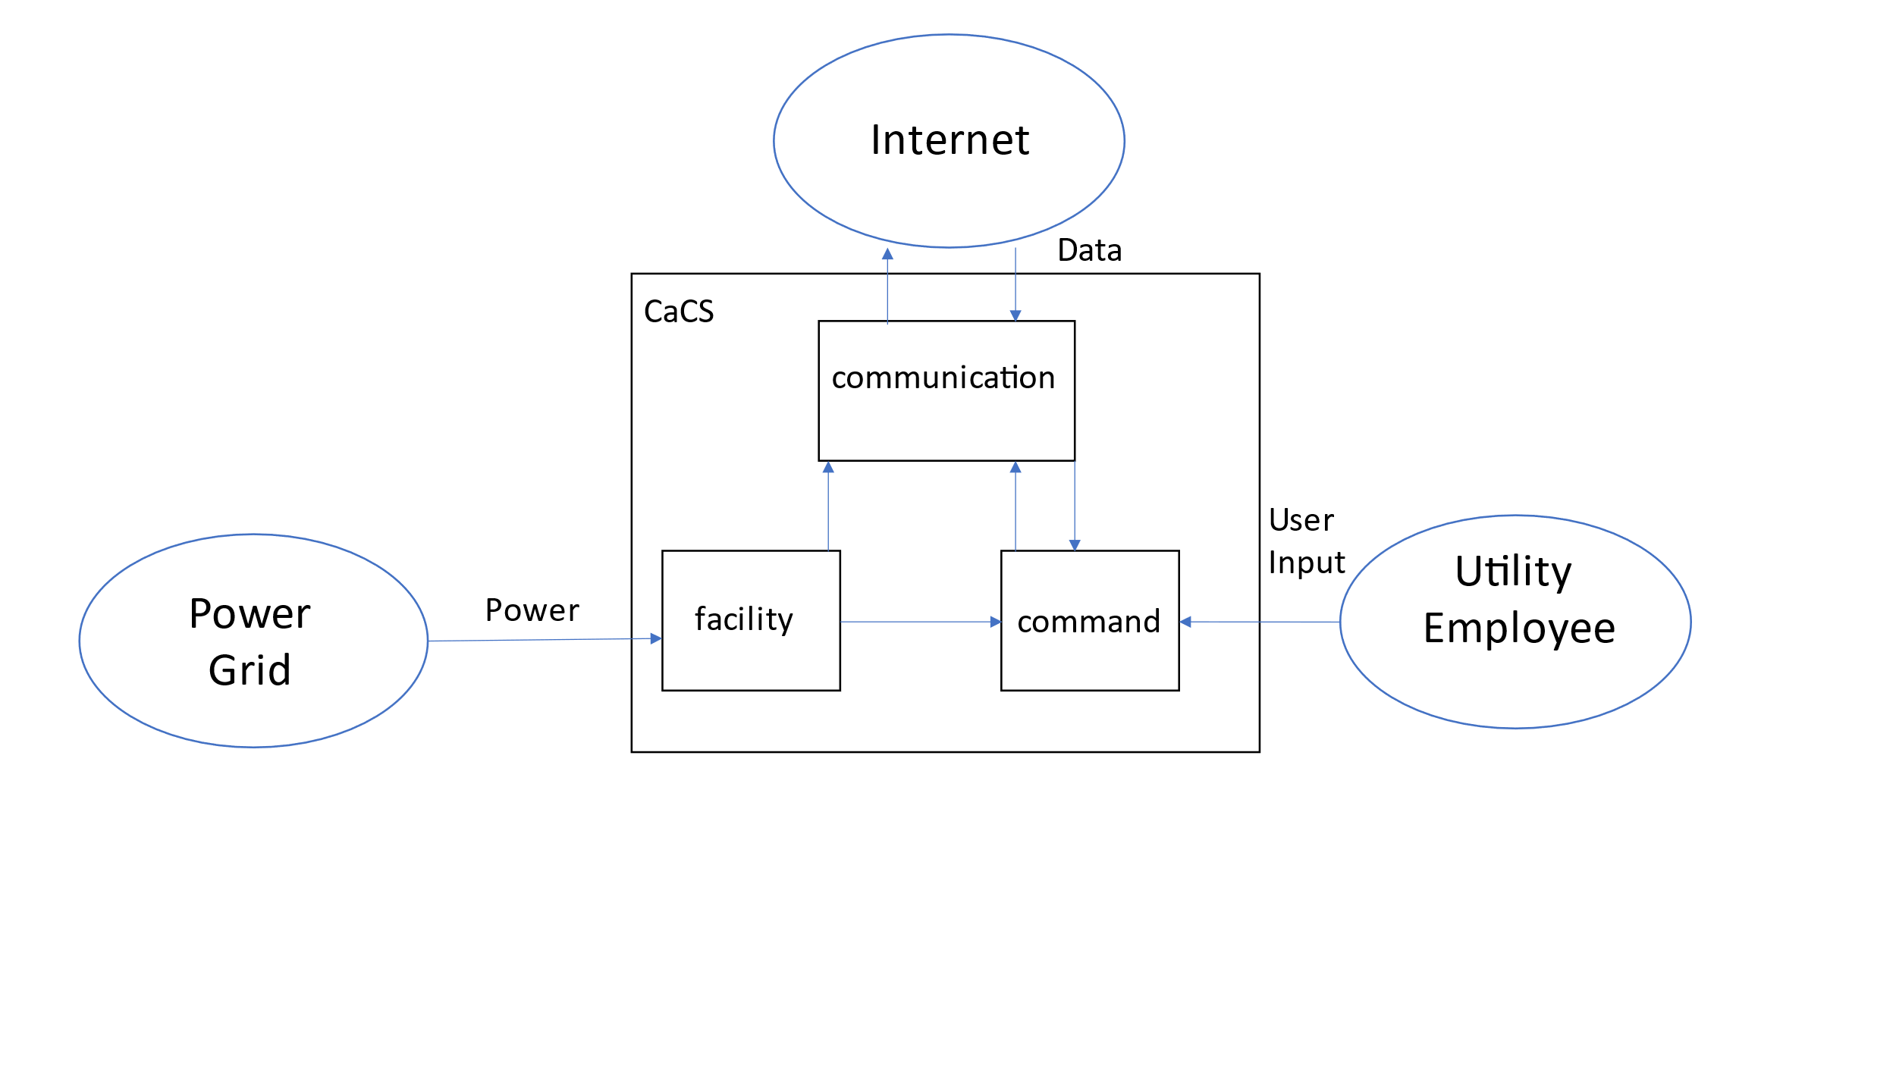

# 3 Component Development

During the CDR, the physical architecture of the full OPESS was developed. The physical block diagrams for the OPESS, ESS and CaCS can be found in this section for reference and comparison to the original block diagrams. However, a complete list of the physical block diagrams can be found in the Appendixes below.

## 3.1 OPESS Physical Block Diagram

The physical block diagram is very similar to the block diagram in section2. Here, the OPESS is broken up into the same two subsystems, interacting with extremal stimuli. However, given the physical nature of this diagram, the linkages connection the subsystem to the stimuli is written in a way that reflects how the system physically interreact rather than functionally. This is true with the exception of the weather interaction. This is because the functional interaction was written in such a way to describe physical protection of the system from weather events. As such, the physical and functional linkages are in essence the same.

Figure : OPESS Physical Block Diagram

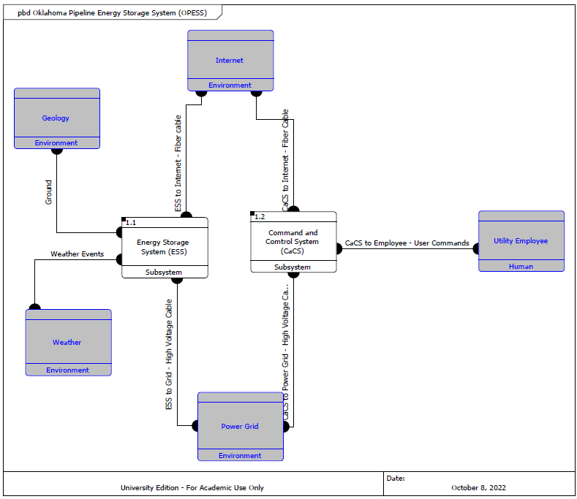

## 3.2 ESS Block Diagram

The ESS is the first block diagram that starts to get complex due to how the CORE software tracks/ For example, linkages. For example, block 1.1.3 links to block 1.1.4. However, the link present here also links 1.1.3 to a subcomponent of 1.1.4. CORE tracks both the high-level link as well as the lower-level link. As such, the diagram is extremely detailed but also a little redundant in places. These links are extremely important however for any subcomponents and devices where they might represent the only link to an outside environment.

Figure : ESS Physical Block Diagram

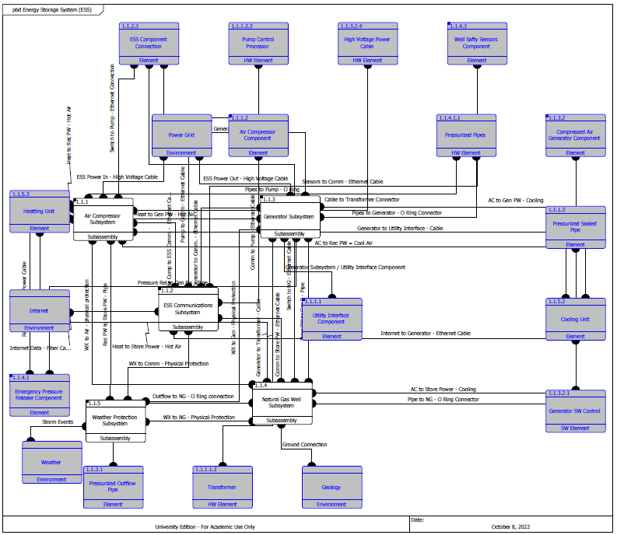

## 3.3 CaCS Block Diagram

The CaCS block diagram is much simpler than the ESS block diagram. The CaCS at its core, represents an office environment. There are still interactions with the outside world through the internet but for the most part, the diagram is much mor internalized.

Figure : CaCS Physical Block Diagram

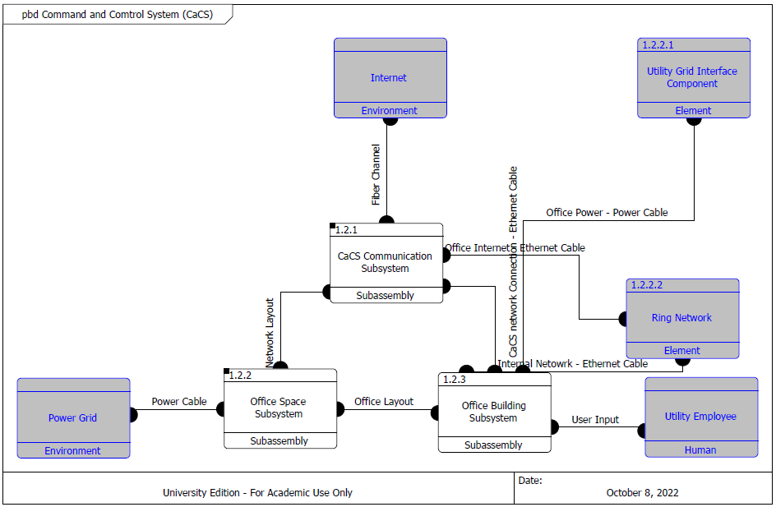

# 4 Requirement Analysis

No changes to the requirements were made during the CAR. As such, this analysis will be reminiscent of the analysis during the TS Report.

## 4.1 System Requirements

The requirements written for the OPESS system can be broken up into four different types:

Originating Requirements: The requirements stem from interviews from experts on various topics. They sometimes fill a performance or functional role in the OPESS system and can mostly be found labeled as both a originating and a performance/functional requirement.

Design Constraint: Design Constraints are choices that were made on the part of a requirement to achieve a goal. For example, “shall store energy” may be a functional phrase but “shall use a natural gas well” is a design choice on the part of the OPESS system.

Performance Requirements: Performance Requirements are any requirement that specifies some measure of performance of the OPESS system. These can be found as percentages, amounts or minimal standards as in the case of some software requirements.

Functional Requirements: Functional Requirements are requirements that provide or describe a function of the system. The phrase “shall store energy” describes a function of the OPESS system.

Table : Requirement Type

|  |  |
| --- | --- |
| Requirement Type | Number |
| Originating Requirements | 21 |
| Design Constraints | 21 |
| Performance Constraints | 40 |
| Functional Constraints | 69 |
| Total | 151 |

Additionally, since some of the Originating Requirements can double as both Functional or Performance most of them have actually been counted twice in the OPESS system with the exception of one. As such, that 151 number presented in Table 6 should actually read 131.

## 4.2 Requirement Verification

The requirements are verified through four verification methods.

Inspection: An inspection requirement is any requirement that can be verified via looking or some form of observation. Potential examples could be something like confirming a piece of software is coded per requirement or looking at a documented spec from a supplier.

Analysis: An analysis requirement is any requirement that requires multiple runs so that data can be built up. This data can then be analyzed to confirm that the behavior meets the requirement.

Demonstration: A demonstration requirement is any requirement that requires a demonstration of the functionality. An example might be like confirming that a pipe can hold up to 30 psi. Once the pipe is filled to that level, the requirement passes.

Test: A test requirement is any requirement that requires some form of formal test procedure. These can be related to demonstration requirements but typically require confirming consistent behavior of the system under multiple situations.

Table : Verification Method

|  |  |
| --- | --- |
| Verification Method | Number |
| Inspection | 43 |
| Analysis | 16 |
| Demonstration | 44 |
| Test | 28 |
| Total | 131 |

## 4.3 Key Performance Parameters

Key performance parameters (KPP’s) are requirements that were developed specifically to dictate key functions or standards important to the OPESS. These requirements form the backbone of the system.

Table : : Key Performance Parameters

|  |  |
| --- | --- |
| Key Performance Parameters | Number |
| True | 12 |
| False | 119 |

Table : KPP Description

| KPP # | Req. # | Req. Name | Req. Description | Quantitative Vs. Qualitative | Verification Method |
| --- | --- | --- | --- | --- | --- |
| 1 | 1.1.1.5 | ESS Internet Interface | The ESS control node shall maintain a secure connection with the CaCS. | Qualitative | VerificationRequirement Test |
| 2 | 1.1.2.1.3 | ESS Generator Storage Interface | The ESS generator shall use compressed air coming from the natural gas well to spin a turbine and generate power. | Qualitative | VerificationRequirement Demonstration |
| 3 | 1.1.2.4.1 | ESS Carbon Capture Percent | The ESS carbon capture system shall remove no less than 50 percent of the hydrocarbons from the compressed air. | Quantitative | VerificationRequirement Test |
| 4 | 1.1.3.2.2 | ESS Storage Time | The ESS storage shall be able to keep compressed air for a period of up to 1 year. | Quantitative | VerificationRequirement Demonstration |
| 5 | 1.1.3.3.2 | ESS Storage Gas Safety Sensor | The ESS pressurized connection shall have an emergency release when the gas mixture reaches 4% according to the sensors. | Quantitative | VerificationRequirement Test |
| 6 | 1.1.3.3.4 | ESS Storage Leak | The ESS shall not allow the pressurized connection to leaked at a rate of more than 5% a year. | Quantitative | VerificationRequirement Test |
| 7 | 1.1.3.3.5 | ESS Storage Pressure | The ESS pressurized connection shall be able to handle up to 300 PSI. | Quantitative | VerificationRequirement Test |
| 8 | 1.1.4.1.1 | ESS Air Compressor | The ESS pump shall compress air and send it to the natural gas interface at pressure. | Qualitative | VerificationRequirement Demonstration |
| 9 | 1.1.5 | ESS Weather | The ESS shall be protected from the weather. | Qualitative | VerificationRequirement Test |
| 10 | 1.2.1.3 | CaCS Syber Security | The CaCS shall have a secure connection to the internet. | Qualitative | VerificationRequirement Test |
| 11 | 1.2.3 | CaCS Utility Interface | The CaCS shall receive data and commands from local utility employees. | Quantitative | VerificationRequirement Demonstration |
| 12 | 1.2.3.6 | CaCS Models | The CaCS shall provide software capable of creating and using utility models. | Qualitative | VerificationRequirement Demonstration |

## 4.4 Requirements Metric

The below table presents a list of all the metrics regarding the requirements derived at this point in time. This table will summarize the number of total requirements, KPP’s, qualitative vs quantitative and how each requirement will be verified.

Table : Requirements Metric

|  |  |  |  |  |  |  |  |  |
| --- | --- | --- | --- | --- | --- | --- | --- | --- |
| Report | Requirements | KPP’s | Qualitative | Quantitative | Inspection | Analysis | Demonstration | Test |
| RAR | 104 | 12 | 50 | 54 | 29 | 14 | 37 | 24 |
| FAR | 129 | 12 | 75 | 54 | 37 | 16 | 48 | 28 |
| TS | 131 | 12 | 79 | 52 | 43 | 16 | 44 | 28 |
| CDR | 131 | 12 | 79 | 52 | 43 | 16 | 44 | 28 |
| TP |  |  |  |  |  |  |  |  |
| A-Spec |  |  |  |  |  |  |  |  |
| Final |  |  |  |  |  |  |  |  |

# 5 Earned Value Management

## 5.1 Schedule

Like what was done during the FAR, the functional work derived during the CDR was based on the block diagrams created during the RAR. Since those, the function and requirements were all already written, the physical architecture was able to be done on time.

Table : CDR Schedule

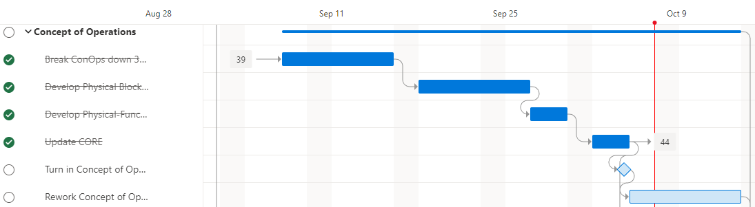

5.2 Milestones Items in red were turned in late per the original due date. All other deliveries are expected to be on time. The CRD was planned to be on time but was pushed back due to work obligations.

Table : Milestones

| **Milestone** | **Date** |
| --- | --- |
| Project Proposal | 7/8/2022 |
| Requirements Report | 8/12/2022 |
| Functional Analysis | 9/2/2022 |
| Trade Study | 9/7/2022 |
| Concept of Operations | 10/8/2022 |
| Test Plan | 11/10/2022 |
| System Specifications | 11/28/2022 |
| Risk Management Report | 12/1/2022 |
| Final Report | 12/13/2022 |
| Oral Presentation | 12/14/2022 |

## 5.3 EVM

Table : EVM

| WBS number | Name | % Complete | Budget | BCWP | ACWP | SPI | CPI |
| --- | --- | --- | --- | --- | --- | --- | --- |
| **5** | **Concept of Operations** | **83.33%** |  |  |  |  |  |
| 5.1 | Break ConOps down 3 levels | 100.00% | 10 | 10.00 | 6 | 1 | 1.67 |
| 5.2 | Develop Physical Block Diagrams | 100.00% | 5 | 5.00 | 3 | 1 | 1.67 |
| 5.3 | Develop Physical-Functional Traceability | 100.00% | 5 | 5.00 | 8 | 1 | 0.63 |
| 5.4 | Update CORE | 100.00% | 2 | 2.00 | 5 | 1 | 0.40 |
| 5.5 | Turn in Concept of Operations | 100.00% | 0.5 | 0.50 | 2 | 1 | 0.25 |

## 5.4 CPI and SPI Index

Figure : CPI and SPI Index

# 6 Risk

No New risks were discovered during the CDR.

## 6.1 Risk 1: Weather

Figure : Risk 1 Weather

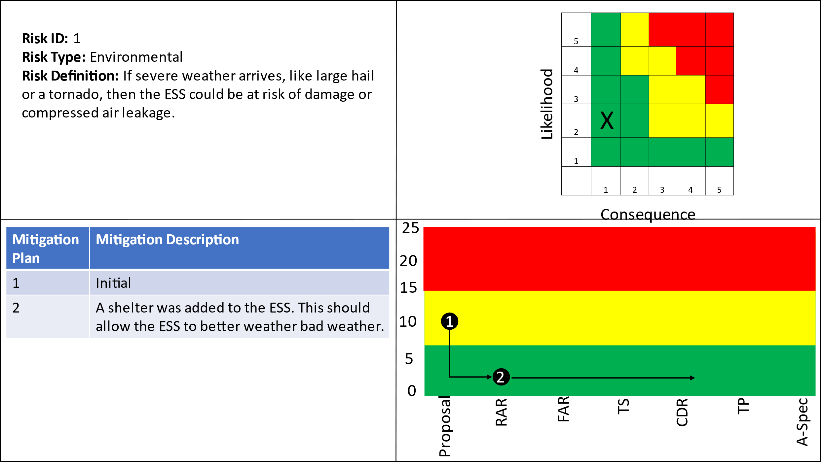

|  |  |  |  |
| --- | --- | --- | --- |
| Requirement Number | Requirement Name | Requirement Number | Requirement Name |
| 1.1.5 | ESS Weather | 1.1.5.1 | ESS Cooling |
| 1.1.5.2 | ESS Hail | 1.1.5.3 | ESS Heating |
| 1.1.5.4 | ESS Tornado | 1.1.5.5 | ESS Wind |
| 1.1.5.6 | Weather Protect | 1.1.5.7 | Climate Control |

## 6.2 Risk 2: Earthquake

Figure : Risk 2 Earthquake

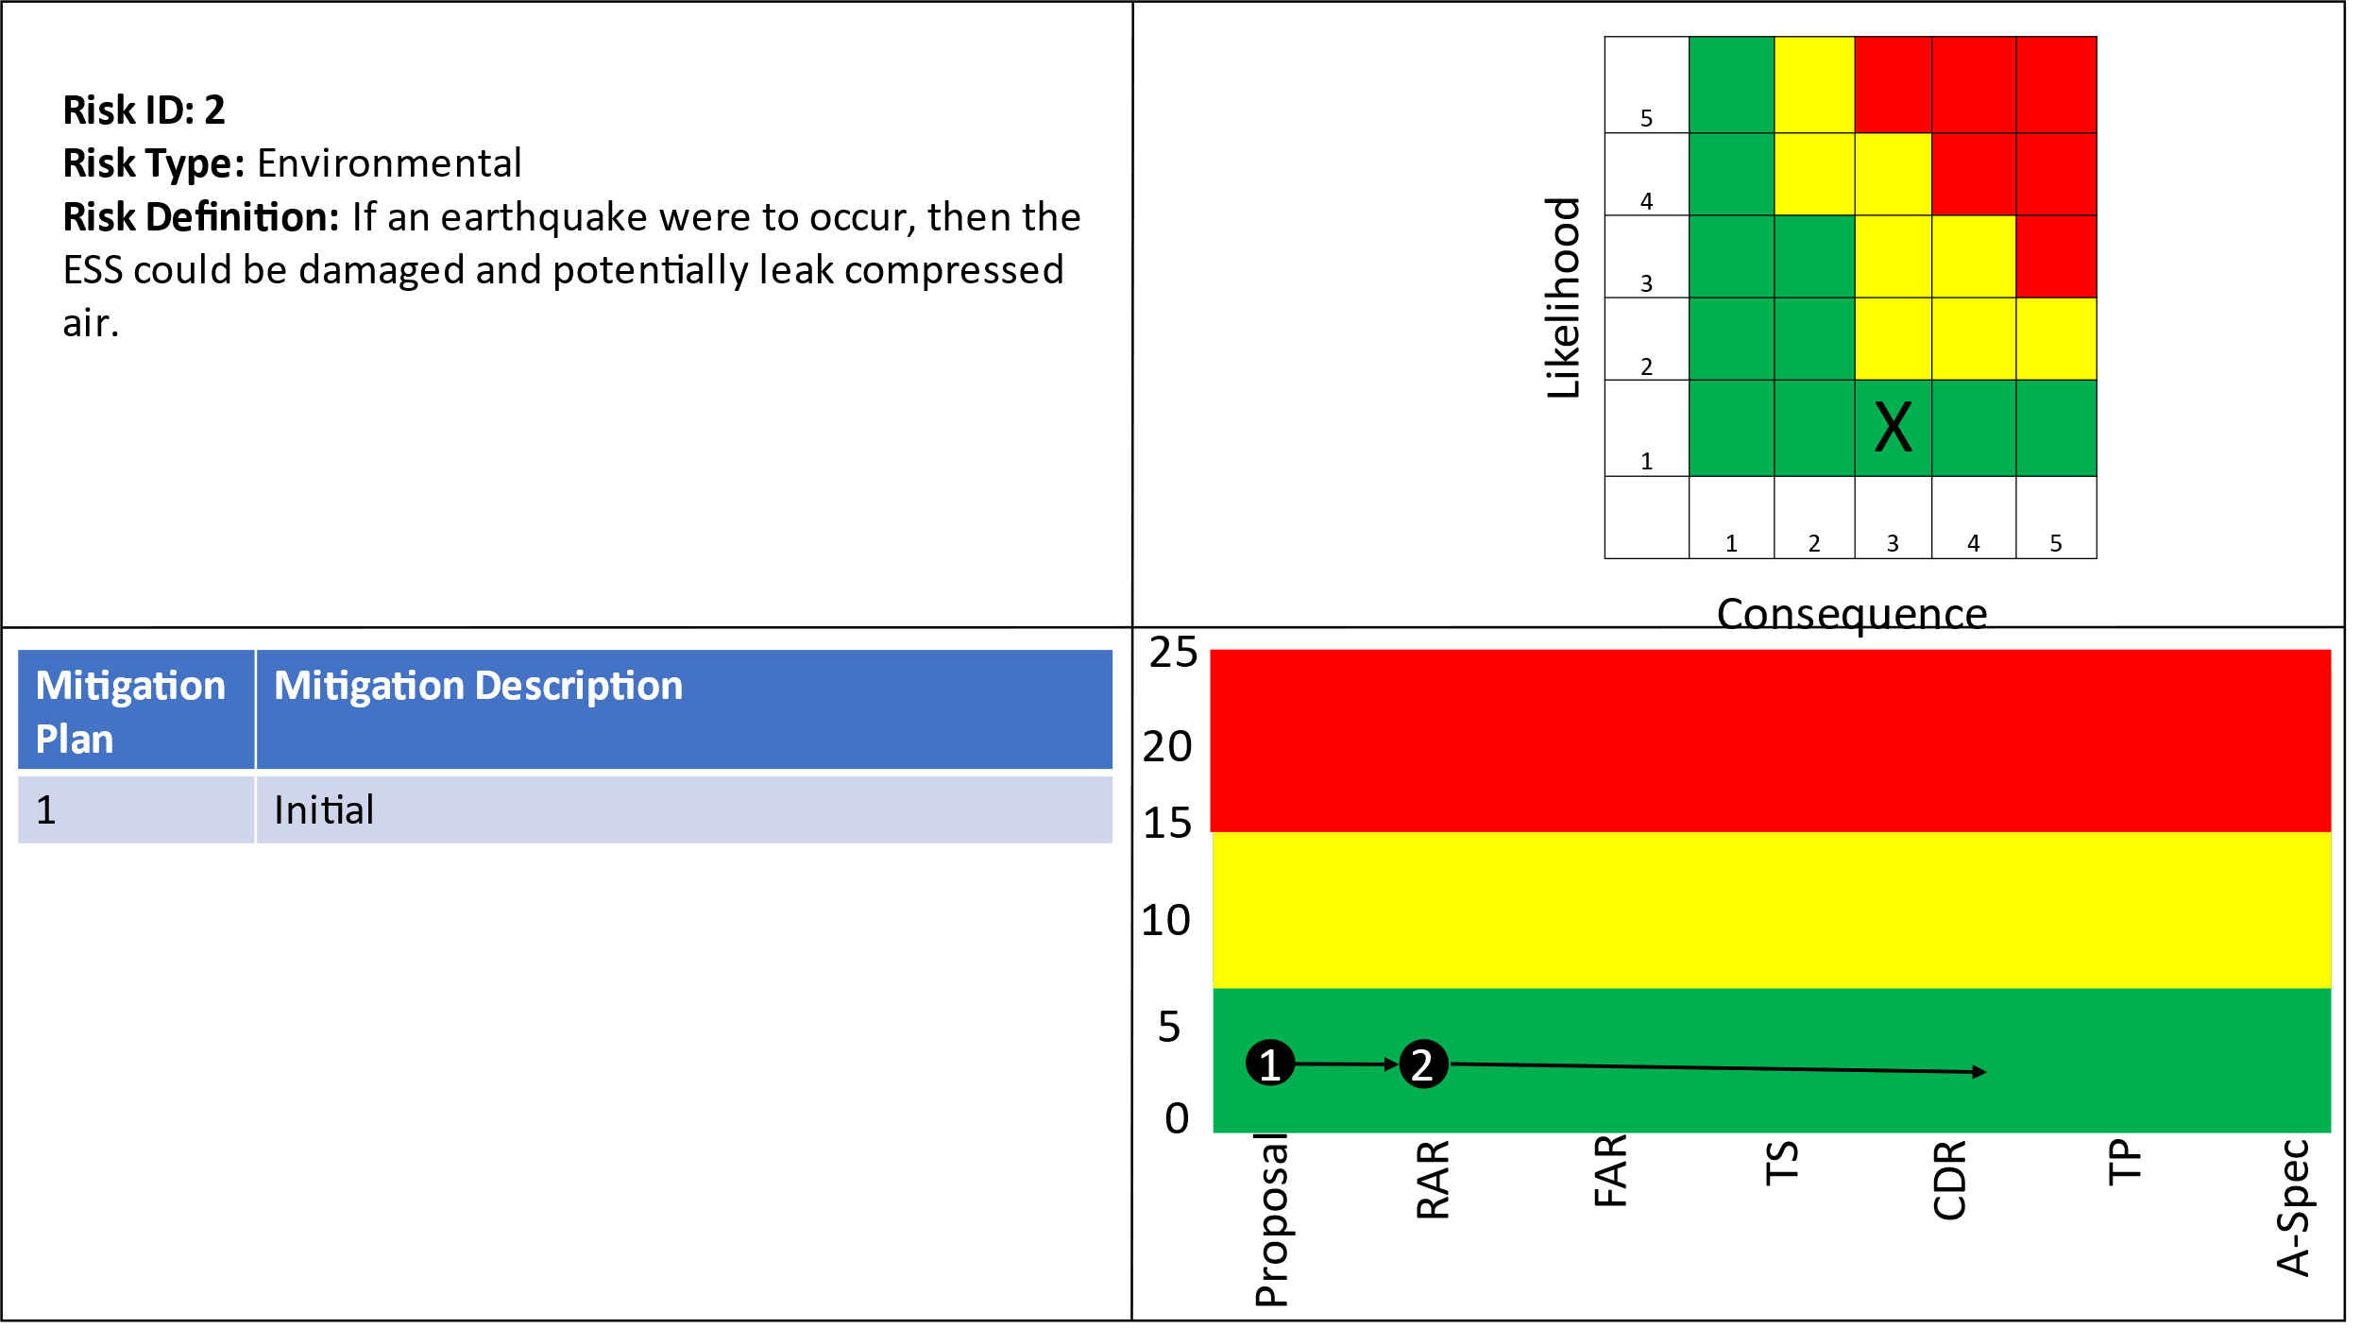

|  |  |  |  |
| --- | --- | --- | --- |
| Requirement Number | Requirement Name | Requirement Number | Requirement Name |
| 1.1.3.1.2 | ESS Storage pressure monitoring |  |  |

## 6.3 Risk 3: Residual Natural Gas

Figure : Risk 3 Residual Natural Gas

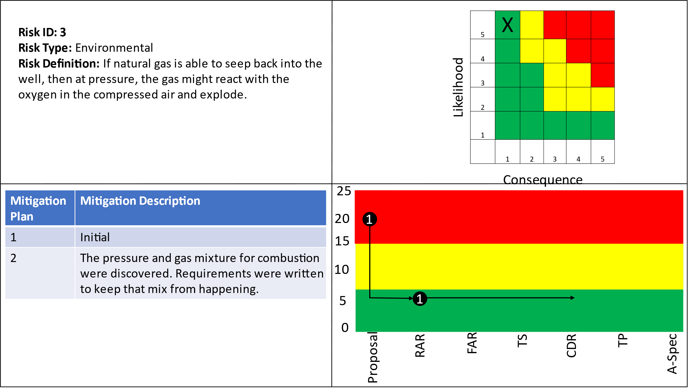

|  |  |  |  |
| --- | --- | --- | --- |
| Requirement Number | Requirement Name | Requirement Number | Requirement Name |
| 1.1.3 | ESS Power Storage | 1.1.3.1 | ESS Compressed air monitoring |
| 1.1.3.1.1 | ESS Gas Monitoring | 1.1.3.1.2 | ESS Storage pressure monitoring |
| 1.1.3.1.3 | ESS Storage Sensors | 1.1.3.1.4 | ESS SW Max Gas mix |
| 1.1.3.1.5 | ESS SW Max PSI | 1.1.3.1.6 | Chemical Monitoring |
| 1.1.3.1.7 | Pressure Monitoring |  |  |

## 6.4 Risk 4: Cyber Security

Figure : Risk 4 Cyber Security

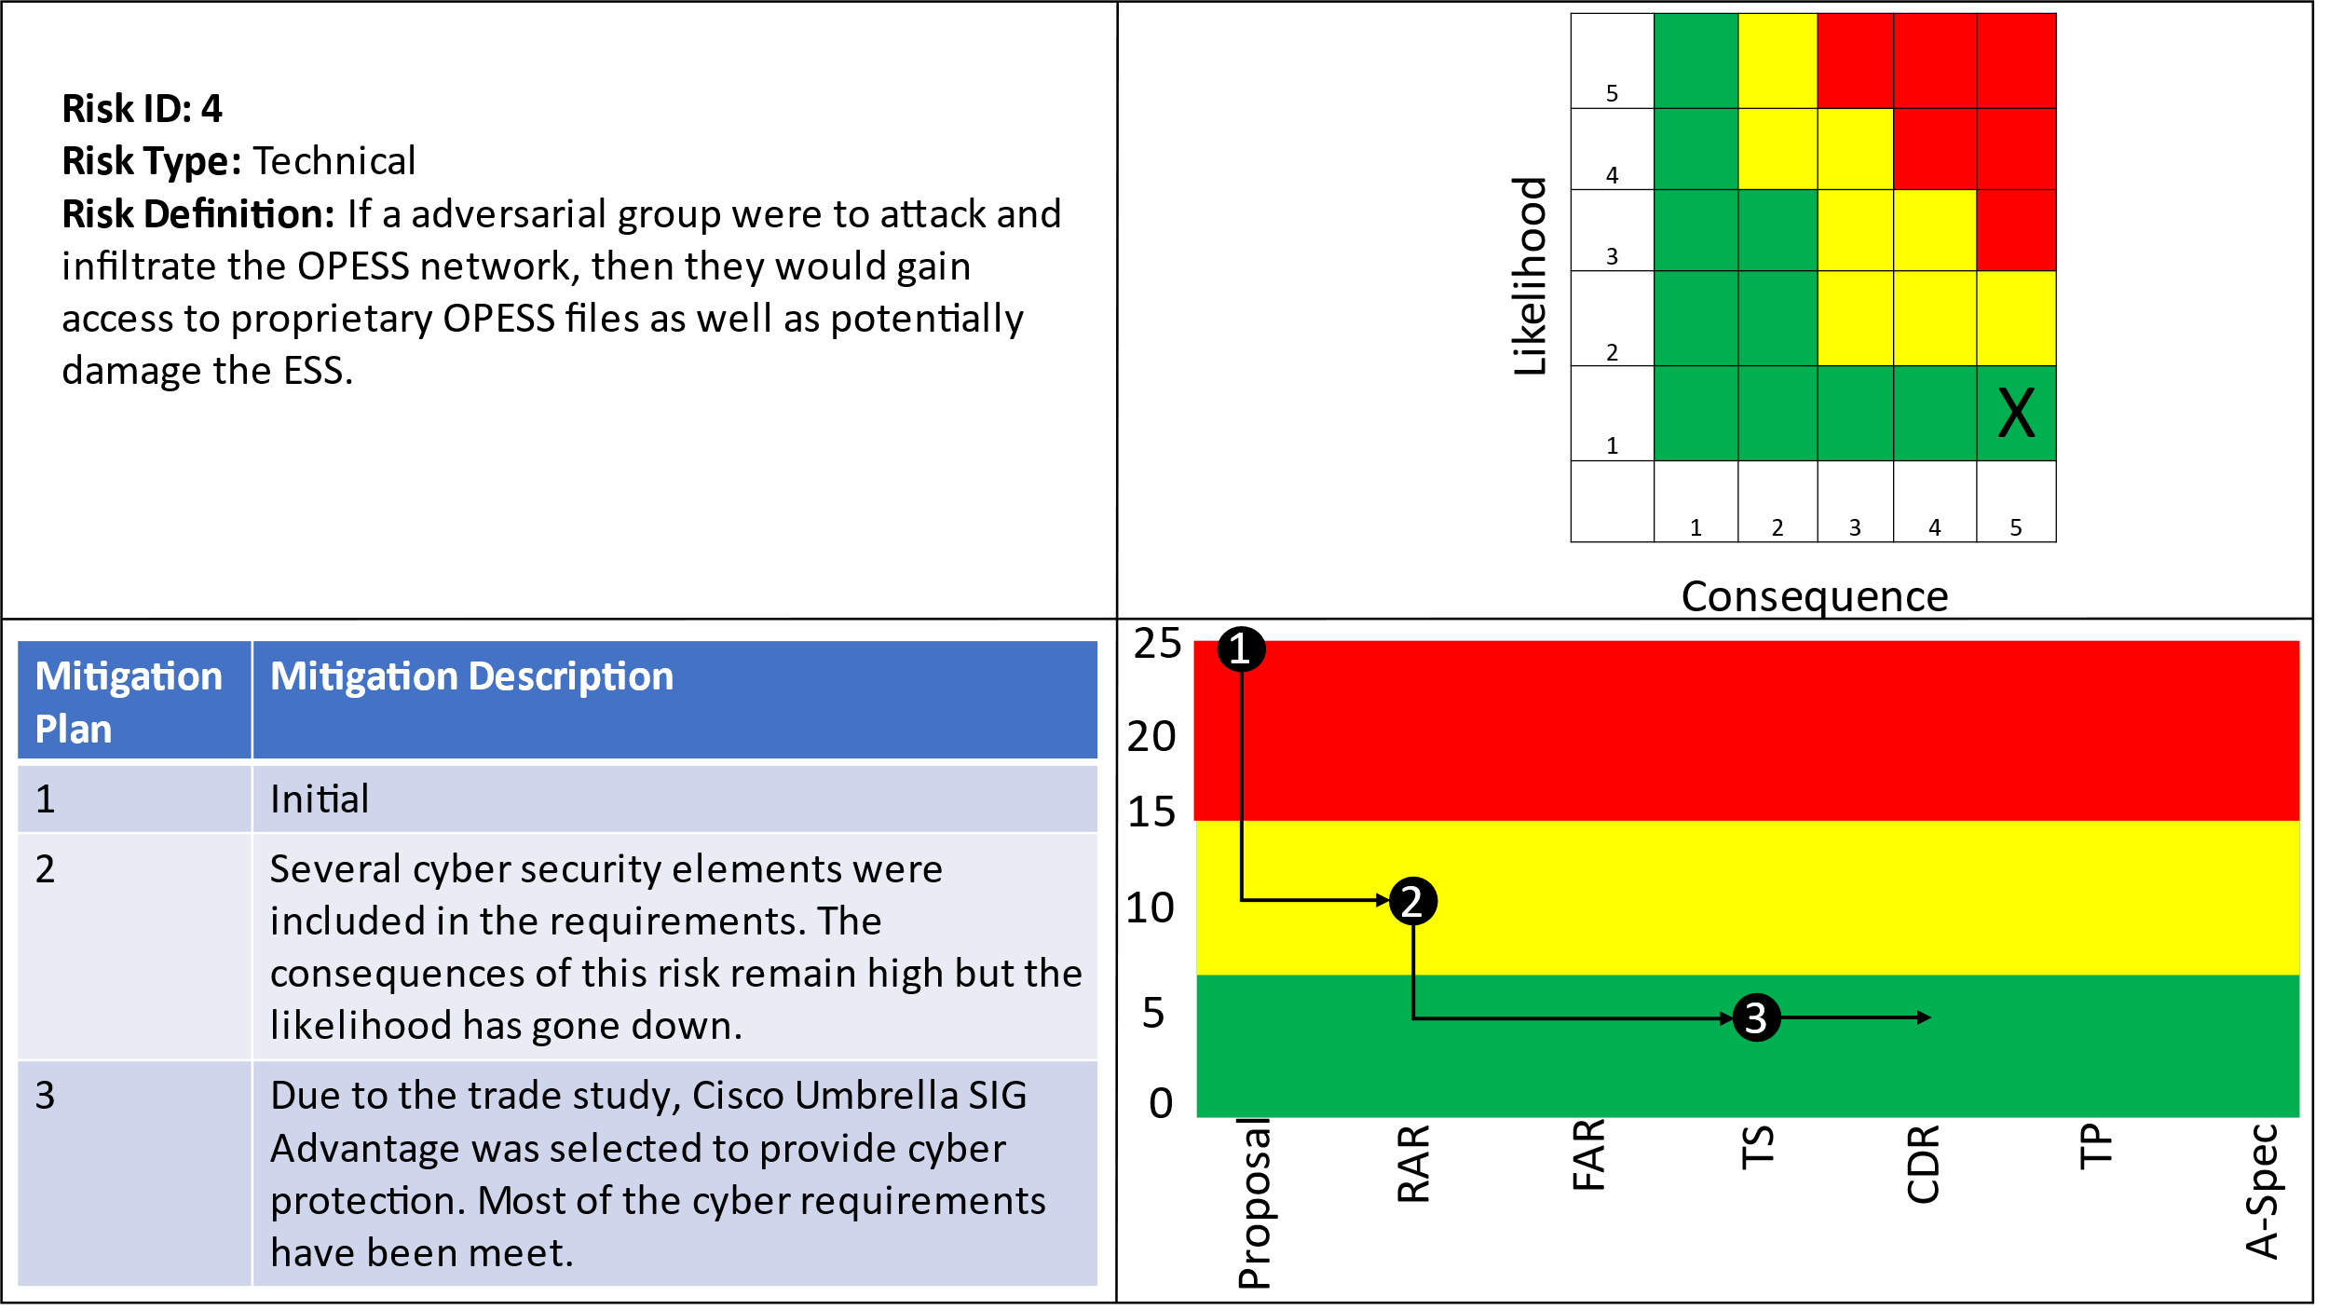

|  |  |  |  |
| --- | --- | --- | --- |
| Requirement Number | Requirement Name | Requirement Number | Requirement Name |
| 1.1.1.5 | ESS Internet Interface | 1.1.1.5.1 | ESS Cyber Scans |
| 1.1.1.5.2 | ESS Encryption | 1.1.1.5.3 | ESS Fiber Optics |
| 1.1.1.5.4 | ESS URL Filtering | 1.1.1.5.6 | ESS TCP/IP |
| 1.1.1.5.8 | ESS Cyber Security Suite | 1.1.1.5.9 | ESS Secure Connection |
| 1.1.1.5.10 | ESS IPS | 1.1.1.5.11 | ESS TLS |
| 1.1.1.5.12 | ESS DDoS Protection | 1.2.1.1.2 | CaCS Log In |
| 1.2.1.1.3 | CaCS Ring Network | 1.2.1.1.4 | CaCS Security Scan |
| 1.2.1.1.5 | CaCS VM | 1.2.1.2 | CaCS Servers |
| 1.2.1.3 | CaCS Syber Security | 1.2.1.3.1 | CaCS Anti-Virus |
| 1.2.1.3.2 | CaCS Cyber Filtering | 1.2.1.3.3 | CaCS Firewall |
| 1.2.1.3.4 | CaCS Intrusion Detection | 1.2.1.3.5 | CaCS TCP/IP |
| 1.2.1.3.6 | CaCS IPS | 1.2.1.3.7 | CaCS TLS |
| 1.2.1.3.8 | CACS DDoS Protection | 1.2.3.1 | CaCS Control |
| 1.2.3.1.1 | CaCS ESS Health and Status | 1.2.3.1.2 | CaCS ESS Interface |
| 1.2.3.1.3 | CaCS Two Factor Authentication |  |  |

# 7 References

Cisco Umbrella Packages. (2022). *Cisco Umbrella*. Retrieved from Cisco: https://umbrella.cisco.com/products/umbrella-enterprise-security-packages

Cloud Flare. (2022). *Application Services*. Retrieved from Cloud Flare : https://www.cloudflare.com/plans/application-services/#overview

*Electricity explained: How electricity is delivered to consumers.* (2022, August 11). Retrieved from US Energy Information Administration: https://www.eia.gov/energyexplained/electricity/delivery-to-consumers.php

Grubelich, M. C., Bauer, S. J., & Cooper, P. W. (2011, September). *Potential Hazards of Compressed Air Energy Storage in Depleted Natural Gas Reservoirs.* Retrieved from Sandia Report: https://www.osti.gov/servlets/purl/1029814/

Popovich, N., & Plumer, B. (2020, 10 28). *How Does Your State Make Electricity?* Retrieved from The New York Times: https://www.nytimes.com/interactive/2020/10/28/climate/how-electricity-generation-changed-in-your-state-election.html

*The Basics of Underground Natural Gas Storage* . (2015, 11 16). Retrieved from US Energy Information Administration: https://www.eia.gov/naturalgas/storage/basics/

U.S. Energy Information Administration. (2022, May 19). *Oklahoma State Profile and Energy Estimates*. Retrieved from U.S. Energy Information Administration: https://www.eia.gov/state/analysis.php?sid=OK

# 8 Appendix A: Physical Block Diagram

Oklahoma Pipeline Energy Storage System (OPESS)

Allocated Functions:

1 Oklahoma Pipeline Energy Storage System

Part I - Hierarchical Component List

1 Oklahoma Pipeline Energy Storage System (OPESS)

1.1 Energy Storage System (ESS)

1.1.1 Air Compressor Subsystem

1.1.1.1 Utility Interface Component

1.1.1.1.1 Grid Connection Device

1.1.1.1.2 Transformer

1.1.1.2 Air Compressor Component

1.1.1.2.1 Pump Power Cable

1.1.1.2.2 Pump H&S Sensors

1.1.1.2.3 Pump Control Processor

1.1.1.2.4 Air Compressor

1.1.1.3 Pressurized Sealed Pipe

1.1.2 ESS Communications Subsystem

1.1.2.1 ESS Internet Connection Component

1.1.2.1.1 ESS Modem

1.1.2.1.2 ESS Firewall

1.1.2.1.3 ESS Router

1.1.2.2 Processor Connection Component

1.1.2.2.1 ESS Commands Processed

1.1.2.2.2 Data Process

1.1.2.2.3 ESS Component H&S Message Processor

1.1.2.3 ESS Component Connection

1.1.3 Generator Subsystem

1.1.3.1 Pressurized Outflow Pipe

1.1.3.2 Compressed Air Generator Component

1.1.3.2.1 Generator SW Control

1.1.3.2.2 Generator H&S Sensor

1.1.3.2.3 Compressed Air Generator

1.1.3.2.4 High Voltage Power Cable

1.1.3.3 Carbon Capture Component

1.1.4 Natural Gas Well Subsystem

1.1.4.1 Emergency Pressure Release Component

1.1.4.1.1 Pressurized Pipes

1.1.4.1.2 Pressure Activated Release Valve

1.1.4.2 Natural Gas Well

1.1.4.3 Well Safety Sensors Component

1.1.4.3.1 Chemical Sensors

1.1.4.3.2 Embedded Pressure Sensors

1.1.5 Weather Protection Subsystem

1.1.5.1 Above Ground Tornado Shelter

1.1.5.2 Cooling Unit

1.1.5.3 Heating Unit

1.2 Command and Control System (CaCS)

1.2.1 CaCS Communication Subsystem

1.2.1.1 CaCS Internet Connection Component

1.2.1.1.1 CaCS Modem

1.2.1.1.2 CaCS Firewall

1.2.1.2 CaCS Cloud Service

1.2.1.3 Router

1.2.2 Office Space Subsystem

1.2.2.1 Utility Grid Interface Component

1.2.2.2 Ring Network

1.2.3 Office Building Subsystem

Part II - Component Definitions

1 Oklahoma Pipeline Energy Storage System (OPESS)

Type: System of Systems

Built From Lower-Level Component(s):

1.1 Energy Storage System (ESS)

1.2 Command and Control System (CaCS)



Figure 1 Oklahoma Pipeline Energy Storage System (OPESS) (Physical Block Diagram)



Figure 2 Oklahoma Pipeline Energy Storage System (OPESS) (Physical N2 Diagram)

Performs Function(s):

1 Oklahoma Pipeline Energy Storage System

1.1 Energy Storage System (ESS)

Type: Subsystem

Built In Higher-Level Component(s):

1 Oklahoma Pipeline Energy Storage System (OPESS)

Built From Lower-Level Component(s):

1.1.1 Air Compressor Subsystem

1.1.2 ESS Communications Subsystem

1.1.3 Generator Subsystem

1.1.4 Natural Gas Well Subsystem

1.1.5 Weather Protection Subsystem

Joined To Logical Interface:

ESS To Internet -Ethernet Cable

Ground



Figure 3 Energy Storage System (ESS) (Physical Block Diagram)



Figure 4 Energy Storage System (ESS) (Physical N2 Diagram)

Connected to Physical Link(s):

ESS to Grid - High Voltage Cable

ESS to Internet - Fiber cable

Ground

Weather Events

Performs Function(s):

1.1 Energy Storage Subsystem

1.1.1 Air Compressor Subsystem

Type: Subassembly

Built In Higher-Level Component(s):

1.1 Energy Storage System (ESS)

Built From Lower-Level Component(s):

1.1.1.1 Utility Interface Component

1.1.1.2 Air Compressor Component

1.1.1.3 Pressurized Sealed Pipe



Figure 5 Air Compressor Subsystem (Physical Block Diagram)



Figure 6 Air Compressor Subsystem (Physical N2 Diagram)

Connected to Physical Link(s):

AC to Rec PW = Cool Air

Air Comp to ESS Comm. - Ethernet Cable

Cable to Transformer Connector

ESS Power In - High Voltage Cable

Generator to Utility Interface - Cable

Heat to Rec PW - Hot Air

Pipes to Pump - O Ring

Rec Pw to Em Rel - Power Cable

Rec PW to Store PW - Pipe

Switch to Pump - Ethernet Connection

WX to Air - physical protection

Performs Function(s):

1.1.1 Receive Power

1.1.1.1 Utility Interface Component

Type: Element

Built In Higher-Level Component(s):

1.1.1 Air Compressor Subsystem

Built From Lower-Level Component(s):

1.1.1.1.1 Grid Connection Device

1.1.1.1.2 Transformer



Figure 7 Utility Interface Component (Physical Block Diagram)



Figure 8 Utility Interface Component (Physical N2 Diagram)

Connected to Physical Link(s):

Generator Subsystem / Utility Interface Component

Grid Interface - High Voltage Cable

Interface to Pump - Power Outlet

Transformer Connection - Power Outlet

Performs Function(s):

1.1.1.1 Utility Interface

1.1.3.4 Generator to Utility Interface

1.1.1.1.1 Grid Connection Device

Type: HW Element

Built In Higher-Level Component(s):

1.1.1.1 Utility Interface Component

Connected to Physical Link(s):

Grid to Interface - High Voltage Cable

Grid to Transformer - Cable

Performs Function(s):

1.1.1.1.1 Power Grid Interface

1.1.3.4.2 Generator to Grid Connection

1.1.1.1.2 Transformer

Type: HW Element

Built In Higher-Level Component(s):

1.1.1.1 Utility Interface Component

Connected to Physical Link(s):

Generator to Transformer - Cable

Grid to Transformer - Cable

Transformer to Pump - Outlet

Performs Function(s):

1.1.1.1.2 Grid to ESS power Adjustment

1.1.3.4.1 Generator to Grid Power Adjustment

1.1.1.2 Air Compressor Component

Type: Element

Built In Higher-Level Component(s):

1.1.1 Air Compressor Subsystem

Built From Lower-Level Component(s):

1.1.1.2.1 Pump Power Cable

1.1.1.2.2 Pump H&S Sensors

1.1.1.2.3 Pump Control Processor

1.1.1.2.4 Air Compressor



Figure 9 Air Compressor Component (Physical Block Diagram)



Figure 10 Air Compressor Component (Physical N2 Diagram)

Connected to Physical Link(s):

Comm to Pump - Ethernet Cable

Interface to Pump - Power Outlet

Pump to NG - O Ring Connector

Transformer to Pump - Outlet

Performs Function(s):

1.1.1.2 Pump

1.1.1.2.1 Pump Power Cable

Type: HW Element

Built In Higher-Level Component(s):

1.1.1.2 Air Compressor Component

Connected to Physical Link(s):

Pump Power Cable Connection

Transformer Connection - Power Outlet

Performs Function(s):

1.1.1.2.1 Pump Power Input

1.1.1.2.2 Pump H&S Sensors

Type: HW Element

Built In Higher-Level Component(s):

1.1.1.2 Air Compressor Component

Connected to Physical Link(s):

H&S to Control - Ethernet Cable

Performs Function(s):

1.1.1.2.2 Pump Health and Status

1.1.1.2.3 Pump Control Processor

Type: HW Element

Built In Higher-Level Component(s):

1.1.1.2 Air Compressor Component

Connected to Physical Link(s):

Compressor Control - Ethernet Cable

H&S to Control - Ethernet Cable

Pump to Comm - Ethernet Cable

Performs Function(s):

1.1.1.2.3 Pump Control

1.1.1.2.4 Air Compressor

Type: HW Element

Built In Higher-Level Component(s):

1.1.1.2 Air Compressor Component

Connected to Physical Link(s):

Compressor Control - Ethernet Cable

Pump Power Cable Connection

Performs Function(s):

1.1.1.2.4 Compressed Air Pump

1.1.1.3 Pressurized Sealed Pipe

Type: Element

Built In Higher-Level Component(s):

1.1.1 Air Compressor Subsystem

Connected to Physical Link(s):

Pipe to NG - O Ring Connector

Pump to NG - O Ring Connector

Performs Function(s):

1.1.1.3 Natural Gas Interface

1.1.2 ESS Communications Subsystem

Type: Subassembly

Built In Higher-Level Component(s):

1.1 Energy Storage System (ESS)

Built From Lower-Level Component(s):

1.1.2.1 ESS Internet Connection Component

1.1.2.2 Processor Connection Component

1.1.2.3 ESS Component Connection



Figure 11 ESS Communications Subsystem (Physical Block Diagram)



Figure 12 ESS Communications Subsystem (Physical N2 Diagram)

Connected to Physical Link(s):

Air Comp to ESS Comm. - Ethernet Cable

Comm to Pump - Ethernet Cable

Comm to Store PW - Ethernet Cable

Generator to Comm. - Ethernet Cable

Internet Data - Fiber Cable

Internet to Generator - Ethernet Cable

Pump to Comm - Ethernet Cable

Sensors to Comm - Ethernet Cable

WX to Comm - Physical Protection

Performs Function(s):

1.1.2 Internet to ESS Control

1.1.6 ESS to Internet-Control

1.1.2.1 ESS Internet Connection Component

Type: Element

Built In Higher-Level Component(s):

1.1.2 ESS Communications Subsystem

Built From Lower-Level Component(s):

1.1.2.1.1 ESS Modem

1.1.2.1.2 ESS Firewall

1.1.2.1.3 ESS Router



Figure 13 ESS Internet Connection Component (Physical Block Diagram)



Figure 14 ESS Internet Connection Component (Physical N2 Diagram)

Connected to Physical Link(s):

AC to Control - Cool Air

Generator to Comm - Ethernet Cable

Heat to Control - Hot Air

Internet to Processor - Ethernet Cable

Internet to ESS connection - Fiber Cable

Processor to Router - Ethernet Cable

Performs Function(s):

1.1.2.1 Internet to ESS-ESS Communications

1.1.6.1 ESS to Internet-ESS Communications

1.1.2.1.1 ESS Modem

Type: HW Element

Built In Higher-Level Component(s):

1.1.2.1 ESS Internet Connection Component

Connected to Physical Link(s):

Internet to Model - Fiber Cable

Modem to Firewall - Network Layer

Performs Function(s):

1.1.2.1.1 ESS Internet Connection

1.1.6.1.1 ESS Connection

1.1.2.1.2 ESS Firewall

Type: SW Element

Built In Higher-Level Component(s):

1.1.2.1 ESS Internet Connection Component

Connected to Physical Link(s):

Firewall to Router - Ethernet Cable

Modem to Firewall - Network Layer

Performs Function(s):

1.1.2.1.2 ESS Cyber Security

1.1.6.1.2 Device Cyber Security

1.1.2.1.3 ESS Router

Type: HW Element

Built In Higher-Level Component(s):

1.1.2.1 ESS Internet Connection Component

Connected to Physical Link(s):

Firewall to Router - Ethernet Cable

Router to Processor - Ethernet Cable

Performs Function(s):

1.1.2.1.3 ESS Network Interface

1.1.6.1.3 ESS Device Connection

1.1.2.2 Processor Connection Component

Type: Element

Built In Higher-Level Component(s):

1.1.2 ESS Communications Subsystem

Built From Lower-Level Component(s):

1.1.2.2.1 ESS Commands Processed

1.1.2.2.2 Data Process

1.1.2.2.3 ESS Component H&S Message Processor



Figure 15 Processor Connection Component (Physical Block Diagram)



Figure 16 Processor Connection Component (Physical N2 Diagram)

Connected to Physical Link(s):

Internet to Processor - Ethernet Cable

Processor to Component - Ethernet Cable

Router to Processor - Ethernet Cable

Performs Function(s):

1.1.2.2 Internet to ESS-Processor

1.1.6.3 ESS to Internet-Processor

1.1.2.2.1 ESS Commands Processed

Type: HW Element

Built In Higher-Level Component(s):

1.1.2.2 Processor Connection Component

Connected to Physical Link(s):

Commands to Processor - SW Connection

Performs Function(s):

1.1.2.2.1 ESS Commands

1.1.6.3.1 Component Commands

1.1.2.2.2 Data Process

Type: HW Element

Built In Higher-Level Component(s):

1.1.2.2 Processor Connection Component

Connected to Physical Link(s):

Commands to Processor - SW Connection

H&S to Processor - SW Connection

Processor to Component - Ethernet Cable

Processor to Router - Ethernet Cable

Performs Function(s):

1.1.2.2.2 Processor Data Link

1.1.6.3.2 Component Processor Data Link

1.1.2.2.3 ESS Component H&S Message Processor

Type: HW Element

Built In Higher-Level Component(s):

1.1.2.2 Processor Connection Component

Connected to Physical Link(s):

H&S to Processor - SW Connection

Performs Function(s):

1.1.2.2.3 ESS Health and Status

1.1.6.3.3 Component Health and Status

1.1.2.3 ESS Component Connection

Type: Element

Built In Higher-Level Component(s):

1.1.2 ESS Communications Subsystem

Connected to Physical Link(s):

Processor to Component - Ethernet Cable

Processor to Component - Ethernet Cable

Switch to Generator - Ethernet Cable

Switch to NG - Ethernet Cable

Switch to Pump - Ethernet Connection

Performs Function(s):

1.1.2.3 Internet to ESS - Component Communications

1.1.6.2 ESS to Internet-Component Communication

1.1.3 Generator Subsystem

Type: Subassembly

Built In Higher-Level Component(s):

1.1 Energy Storage System (ESS)

Built From Lower-Level Component(s):

1.1.3.1 Pressurized Outflow Pipe

1.1.3.2 Compressed Air Generator Component

1.1.3.3 Carbon Capture Component



Figure 17 Generator Subsystem (Physical Block Diagram)



Figure 18 Generator Subsystem (Physical N2 Diagram)

Connected to Physical Link(s):

AC to Gen PW - Cooling

ESS Power Out - High Voltage Cable

Generator Subsystem / Utility Interface Component

Generator to Comm. - Ethernet Cable

Generator to Transformer - Cable

Heat to Gen PW - Hot Air

Pipes to Generator - O Ring Connector

Pressure Rel to Gen Pw - Pipe

Store PW to Gen P - Pipe

Switch to Generator - Ethernet Cable

WX to Gen - Physical Protection

Performs Function(s):

1.1.3 Generate Power

1.1.3.1 Pressurized Outflow Pipe

Type: Element

Built In Higher-Level Component(s):

1.1.3 Generator Subsystem

Connected to Physical Link(s):

Outflow to NG - O Ring connection

Pipe top Generator - E Ring Connection

Performs Function(s):

1.1.3.1 Generate Power Natural Gas Interface

1.1.3.2 Compressed Air Generator Component

Type: Element

Built In Higher-Level Component(s):

1.1.3 Generator Subsystem

Built From Lower-Level Component(s):

1.1.3.2.1 Generator SW Control

1.1.3.2.2 Generator H&S Sensor

1.1.3.2.3 Compressed Air Generator

1.1.3.2.4 High Voltage Power Cable



Figure 19 Compressed Air Generator Component (Physical Block Diagram)



Figure 20 Compressed Air Generator Component (Physical N2 Diagram)

Connected to Physical Link(s):

Generator to Carbon Capture - Pipe

Generator to Comm - Ethernet Cable

Generator to Utility Interface - Cable

Pipe top Generator - E Ring Connection

Performs Function(s):

1.1.3.2 Generator

1.1.3.2.1 Generator SW Control

Type: SW Element

Built In Higher-Level Component(s):

1.1.3.2 Compressed Air Generator Component

Connected to Physical Link(s):

Gen Control to Gen - Ethernet Cable

H&S to Gen Control - Ethernet Cable

Internet to Generator - Ethernet Cable

Performs Function(s):

1.1.3.2.1 Generator Control

1.1.3.2.2 Generator H&S Sensor

Type: HW Element

Built In Higher-Level Component(s):

1.1.3.2 Compressed Air Generator Component

Connected to Physical Link(s):

H&S to Gen Control - Ethernet Cable

Performs Function(s):

1.1.3.2.2 Generator Health and Status

1.1.3.2.3 Compressed Air Generator

Type: HW Element

Built In Higher-Level Component(s):

1.1.3.2 Compressed Air Generator Component

Connected to Physical Link(s):

Gen Control to Gen - Ethernet Cable

Generator to Power Interface - Cable

Performs Function(s):

1.1.3.2.3 Electrical Generator

1.1.3.2.4 High Voltage Power Cable

Type: HW Element

Built In Higher-Level Component(s):

1.1.3.2 Compressed Air Generator Component

Connected to Physical Link(s):

Cable to Transformer Connector

Generator to Power Interface - Cable

Performs Function(s):

1.1.3.2.4 Generator Power Output

1.1.3.3 Carbon Capture Component

Type: HW Element

Built In Higher-Level Component(s):

1.1.3 Generator Subsystem

Connected to Physical Link(s):

Air Released - Exhaust

Generator to Carbon Capture - Pipe

Performs Function(s):

1.1.3.3 Carbon Capture

1.1.4 Natural Gas Well Subsystem

Type: Subassembly

Built In Higher-Level Component(s):

1.1 Energy Storage System (ESS)

Built From Lower-Level Component(s):

1.1.4.1 Emergency Pressure Release Component

1.1.4.2 Natural Gas Well

1.1.4.3 Well Safety Sensors Component



Figure 21 Natural Gas Well Subsystem (Physical Block Diagram)



Figure 22 Natural Gas Well Subsystem (Physical N2 Diagram)

Connected to Physical Link(s):

AC to Store Power - Cooling

Comm to Store PW - Ethernet Cable

Ground Connection

Heat to Store Power - Hot Air

Outflow to NG - O Ring connection

Pipe to NG - O Ring Connector

Rec PW to Store PW - Pipe

Store PW to Gen P - Pipe

Switch to NG - Ethernet Cable

WX to NG - Physical Protection

Performs Function(s):

1.1.4 Store Power

1.1.4.1 Emergency Pressure Release Component

Type: Element

Built In Higher-Level Component(s):

1.1.4 Natural Gas Well Subsystem

Built From Lower-Level Component(s):

1.1.4.1.1 Pressurized Pipes

1.1.4.1.2 Pressure Activated Release Valve



Figure 23 Emergency Pressure Release Component (Physical Block Diagram)



Figure 24 Emergency Pressure Release Component (Physical N2 Diagram)

Connected to Physical Link(s):

NG to Em Rel - Auto Release Valve

Pressure Rel to Gen Pw - Pipe

Rec Pw to Em Rel - Power Cable

Performs Function(s):

1.1.4.1 Pressure Release

1.1.4.1.1 Pressurized Pipes

Type: HW Element

Built In Higher-Level Component(s):

1.1.4.1 Emergency Pressure Release Component

Connected to Physical Link(s):

Pipes to Generator - O Ring Connector

Pipes to NG well - Pressurized connector

Pipes to Pump - O Ring

Valve to Pipes - Pressurized connector

Performs Function(s):

1.1.4.1.1 Maintain Pressure

1.1.4.1.2 Pressure Activated Release Valve

Type: HW Element

Built In Higher-Level Component(s):

1.1.4.1 Emergency Pressure Release Component

Connected to Physical Link(s):

Valve to Pipes - Pressurized connector

Performs Function(s):

1.1.4.1.2 Pressure Safety Release

1.1.4.2 Natural Gas Well

Type: Element

Built In Higher-Level Component(s):

1.1.4 Natural Gas Well Subsystem

Connected to Physical Link(s):

Chem Sensor to NG - Ethernet Cable

NG to Em Rel - Auto Release Valve

Pipes to NG well - Pressurized connector

Press Sensor to Geo - Ethernet Cable

Sensor to NG - Sensor HW Placement

Performs Function(s):

1.1.4.2 Natural Gas Well Storage

1.1.4.3 Well Safety Sensors Component

Type: Element

Built In Higher-Level Component(s):

1.1.4 Natural Gas Well Subsystem

Built From Lower-Level Component(s):

1.1.4.3.1 Chemical Sensors

1.1.4.3.2 Embedded Pressure Sensors



Figure 25 Well Safety Sensors Component (Physical Block Diagram)



Figure 26 Well Safety Sensors Component (Physical N2 Diagram)

Connected to Physical Link(s):

NG Ground Impacts

Sensor to NG - Sensor HW Placement

Sensors to Comm - Ethernet Cable

Performs Function(s):

1.1.4.3 Well Safety

1.1.4.3.1 Chemical Sensors

Built In Higher-Level Component(s):

1.1.4.3 Well Safety Sensors Component

Connected to Physical Link(s):

Chem Sensor to Geo - Chemical Measurement

Chem Sensor to NG - Ethernet Cable

Performs Function(s):

1.1.4.3.1 Gas Sensors

1.1.4.3.2 Embedded Pressure Sensors

Type: HW Element

Built In Higher-Level Component(s):

1.1.4.3 Well Safety Sensors Component

Connected to Physical Link(s):

Press Sensor to Geo - Ambient Pressure

Press Sensor to Geo - Ethernet Cable

Performs Function(s):

1.1.4.3.2 Pressure Sensors

1.1.5 Weather Protection Subsystem

Type: Subassembly

Built In Higher-Level Component(s):

1.1 Energy Storage System (ESS)

Built From Lower-Level Component(s):

1.1.5.1 Above Ground Tornado Shelter

1.1.5.2 Cooling Unit

1.1.5.3 Heating Unit



Figure 27 Weather Protection Subsystem (Physical Block Diagram)



Figure 28 Weather Protection Subsystem (Physical N2 Diagram)

Connected to Physical Link(s):

Storm Events

WX to Air - physical protection

WX to Comm - Physical Protection

WX to Gen - Physical Protection

WX to NG - Physical Protection

Performs Function(s):

1.1.5 Weather Protection

1.1.5.1 Above Ground Tornado Shelter

Type: Element

Built In Higher-Level Component(s):

1.1.5 Weather Protection Subsystem

Connected to Physical Link(s):

Environmental Impact

Steal cover for AC

Steal cover for Heat

Performs Function(s):

1.1.5.1 Exterior Protection

1.1.5.2 Cooling Unit

Type: Element

Built In Higher-Level Component(s):

1.1.5 Weather Protection Subsystem

Connected to Physical Link(s):

AC to Control - Cool Air

AC to Gen PW - Cooling

AC to Rec PW = Cool Air

AC to Store Power - Cooling

Steal cover for AC

Performs Function(s):

1.1.5.2 Climate Control

1.1.5.3 Heating Unit

Type: Element

Built In Higher-Level Component(s):

1.1.5 Weather Protection Subsystem

Connected to Physical Link(s):

Heat to Control - Hot Air

Heat to Gen PW - Hot Air

Heat to Rec PW - Hot Air

Heat to Store Power - Hot Air

Steal cover for Heat

Performs Function(s):

1.1.5.2 Climate Control

1.2 Command and Control System (CaCS)

Type: Subsystem

Built In Higher-Level Component(s):

1 Oklahoma Pipeline Energy Storage System (OPESS)

Built From Lower-Level Component(s):

1.2.1 CaCS Communication Subsystem

1.2.2 Office Space Subsystem

1.2.3 Office Building Subsystem



Figure 29 Command and Control System (CaCS) (Physical Block Diagram)



Figure 30 Command and Control System (CaCS) (Physical N2 Diagram)

Connected to Physical Link(s):

CaCS to Employee - User Commands

CaCS to Internet - Fiber Cable

CaCS to Power Grid - High Voltage Cable

Performs Function(s):

1.2 Command and Control Subsystem

1.2.1 CaCS Communication Subsystem

Type: Subassembly

Built In Higher-Level Component(s):

1.2 Command and Control System (CaCS)

Built From Lower-Level Component(s):

1.2.1.1 CaCS Internet Connection Component

1.2.1.2 CaCS Cloud Service

1.2.1.3 Router



Figure 31 CaCS Communication Subsystem (Physical Block Diagram)



Figure 32 CaCS Communication Subsystem (Physical N2 Diagram)

Connected to Physical Link(s):

CaCS network Connection - Ethernet Cable

Fiber Channel

Network Layout

Office Internet - Ethernet Cable

Performs Function(s):

1.2.1 Internet to CaCS Communication

1.2.4 CaCS to Internet Communication

1.2.1.1 CaCS Internet Connection Component

Type: Element

Built In Higher-Level Component(s):

1.2.1 CaCS Communication Subsystem

Built From Lower-Level Component(s):

1.2.1.1.1 CaCS Modem

1.2.1.1.2 CaCS Firewall



Figure 33 CaCS Internet Connection Component (Physical Block Diagram)



Figure 34 CaCS Internet Connection Component (Physical N2 Diagram)

Connected to Physical Link(s):

Cloud to Internet - Fiber Cable

Communication to Internet - Fiber Cable

Internet to Modem - Ethernet Cable

Performs Function(s):

1.2.1.1 Internet Communication

1.2.4.1 CaCS Communication

1.2.1.1.1 CaCS Modem

Type: HW Element

Built In Higher-Level Component(s):

1.2.1.1 CaCS Internet Connection Component

Connected to Physical Link(s):

Internet to Modem - Fiber Cable

Network Layer Messages

Performs Function(s):

1.2.1.1.1 Inbound Internet Connection

1.2.4.1.2 Outbound Internet Connection

1.2.1.1.2 CaCS Firewall

Type: HW Element

Built In Higher-Level Component(s):

1.2.1.1 CaCS Internet Connection Component

Connected to Physical Link(s):

Firewall to Cloud - Network Layer

Modem to Router - Ethernet Cable

Network Layer Messages

Performs Function(s):

1.2.1.1.2 Internet Cyber Security

1.2.4.1.1 CaCS Cyber Security

1.2.1.2 CaCS Cloud Service

Type: Element

Built In Higher-Level Component(s):

1.2.1 CaCS Communication Subsystem

Connected to Physical Link(s):

Cloud to Internet - Fiber Cable

Firewall to Cloud - Network Layer

Performs Function(s):

1.2.1.2 Internet Cloud Connection

1.2.4.2 CaCS Cloud Connection

1.2.1.3 Router

Type: Element

Built In Higher-Level Component(s):

1.2.1 CaCS Communication Subsystem

Connected to Physical Link(s):

Internet to Modem - Ethernet Cable

Modem to Router - Ethernet Cable

Performs Function(s):

1.2.1.3 Internet to Internal Network

1.2.4.3 Internal Network to Internet

1.2.2 Office Space Subsystem

Type: Subassembly

Built In Higher-Level Component(s):

1.2 Command and Control System (CaCS)

Built From Lower-Level Component(s):

1.2.2.1 Utility Grid Interface Component

1.2.2.2 Ring Network



Figure 35 Office Space Subsystem (Physical Block Diagram)



Figure 36 Office Space Subsystem (Physical N2 Diagram)

Connected to Physical Link(s):

Network Layout

Office Layout

Power Cable

Performs Function(s):

1.2.2 CaCS Work Space

1.2.2.1 Utility Grid Interface Component

Type: Element

Built In Higher-Level Component(s):

1.2.2 Office Space Subsystem

Connected to Physical Link(s):

Office Power - Power Cable

Office Power Cable

Performs Function(s):

1.2.3.1 Facility Power

1.2.2.2 Ring Network

Type: Element

Built In Higher-Level Component(s):

1.2.2 Office Space Subsystem

Connected to Physical Link(s):

Internal Network - Ethernet Cable

Office Internet - Ethernet Cable

Performs Function(s):

1.2.3.2 Office Network

1.2.3 Office Building Subsystem

Type: Subassembly

Built In Higher-Level Component(s):

1.2 Command and Control System (CaCS)

Connected to Physical Link(s):

CaCS network Connection - Ethernet Cable

Internal Network - Ethernet Cable

Office Layout

Office Power - Power Cable

User Input

Performs Function(s):

1.2.3 Facility

# 9 Appendix B: Component to Requirement Traceability Matrix

| Function Number | Function Name | Component Name | Requirement | Functional Input | Functional Output |
| --- | --- | --- | --- | --- | --- |
| 1 | Oklahoma Pipeline Energy Storage System | Component 1 Oklahoma Pipeline Energy Storage System (OPESS) | Requirement 1 OPESS Requirements |  |  |
| 1.1 | Energy Storage Subsystem | Component 1.1 Energy Storage System (ESS) | Requirement 1.1 ESS Requirement | Item CaCS to ESS (data over Internet) Item Geology Item Power Grid (Electricity) Item Weather | Item ESS to CaCS (Data over Internet) Item Power Grid (Electricity) |
| 1.1.1 | Receive Power | Component 1.1.1 Air Compressor Subsystem | Requirement 1.1.4 ESS Receive Power | Item ESS Commands Item Power Grid (Electricity) Item Weather Protection | Item Compressed Air (To NG) Item Receive Power Health and Status |
| 1.1.1.1 | Utility Interface | Component 1.1.1.1 Utility Interface Component | Requirement 1.1.4.2 ESS Power Intake | Item Power Grid (Electricity) Item Weather Protection | Item ESS Process Electricity |
| 1.1.1.1.1 | Power Grid Interface | Component 1.1.1.1.1 Grid Connection Device | Requirement 1.1.4.2.1 ESS Power Connection | Item Power Grid (Electricity) | Item High Voltage |
| 1.1.1.1.2 | Grid to ESS power Adjustment | Component 1.1.1.1.2 Transformer | Requirement 1.1.4.2.2 ESS Transformer Requirement 1.1.4.2.3 ESS Voltage Adjust | Item High Voltage | Item ESS Process Electricity |
| 1.1.1.2 | Pump | Component 1.1.1.2 Air Compressor Component | Requirement 1.1.4.1 ESS Air Pump | Item Controller Pump Command Item ESS Process Electricity Item Weather Protection | Item Air (from Pump) Item Receive Power Health and Status |
| 1.1.1.2.1 | Pump Power Input | Component 1.1.1.2.1 Pump Power Cable | Requirement 1.1.4.1.5 ESS Transformer Connection | Item ESS Process Electricity | Item Pump Communication |
| 1.1.1.2.2 | Pump Health and Status | Component 1.1.1.2.2 Pump H&S Sensors | Requirement 1.1.1.1.1 ESS Health and Status Send Requirement 1.1.4.1.3 ESS Health and Status | Item Pump Communication | Item Pump HaS |
| 1.1.1.2.3 | Pump Control | Component 1.1.1.2.3 Pump Control Processor | Requirement 1.1.4.1.2 ESS Command | Item Controller Pump Command Item Pump HaS | Item Pump Control Command Item Receive Power Health and Status |
| 1.1.1.2.4 | Compressed Air Pump | Component 1.1.1.2.4 Air Compressor | Requirement 1.1.4.1.6 ESS Compressed Air | Item Pump Control Command Item Weather | Item Air (from Pump) |
| 1.1.1.3 | Natural Gas Interface | Component 1.1.1.3 Pressurized Sealed Pipe | Requirement 1.1.4.1.1 ESS Air Compressor Requirement 1.1.4.1.7 Compressed Air Transport Requirement 1.1.4.3 ESS Pump Storage Interface | Item Air (from Pump) Item Weather Protection | Item Air (to Natural Gas) |
| 1.1.2 | Internet to ESS Control | Component 1.1.2 ESS Communications Subsystem | Requirement 1.1.1 ESS Communications | Item CaCS to ESS (data over Internet) | Item ESS Commands |
| 1.1.2.1 | Internet to ESS-ESS Communications | Component 1.1.2.1 ESS Internet Connection Component | Requirement 1.1.1.5 ESS Internet Interface | Item CaCS to ESS (data over Internet) | Item Secure Network Output |
| 1.1.2.1.1 | ESS Internet Connection | Component 1.1.2.1.1 ESS Modem | Requirement 1.1.1.5.5 ESS High Speed Internet Requirement 1.1.1.5.6 ESS TCP/IP Requirement 1.1.1.5.7 ESS Internet Connection | Item CaCS to ESS (data over Internet) | Item Raw Inbound TCP/IP |
| 1.1.2.1.2 | ESS Cyber Security | Component 1.1.2.1.2 ESS Firewall | Requirement 1.1.1.5.1 ESS Cyber Scans Requirement 1.1.1.5.2 ESS Encryption Requirement 1.1.1.5.4 ESS URL Filtering Requirement 1.1.1.5.8 ESS Cyber Security Suite Requirement 1.1.1.5.10 ESS IPS Requirement 1.1.1.5.11 ESS TLS Requirement 1.1.1.5.12 ESS DDoS Protection | Item Raw Inbound TCP/IP | Item Inbound Internal Network |
| 1.1.2.1.3 | ESS Network Interface | Component 1.1.2.1.3 ESS Router | Requirement 1.1.1.5.3 ESS Fiber Optics Requirement 1.1.1.5.9 ESS Secure Connection | Item Inbound Internal Network | Item Secure Network Output |
| 1.1.2.2 | Internet to ESS-Processor | Component 1.1.2.2 Processor Connection Component | Requirement 1.1.1.1 ESS Control | Item Secure Network Output Item Weather Protection | Item ESS Processor Commands |
| 1.1.2.2.1 | ESS Commands | Component 1.1.2.2.1 ESS Commands Processed | Requirement 1.1.1.1.2 ESS Processor Communication Requirement 1.1.1.1.5 ESS Command Process Requirement 1.1.1.4 ESS Control Node Send Commands | Item Processor Commands ACK | Item Commands to Processor |
| 1.1.2.2.2 | Processor Data Link | Component 1.1.2.2.2 Data Process | Requirement 1.1.1.1.6 ESS to Component Connection | Item Commands to Processor Item Processor HaS Item Secure Network Output | Item ESS Processor Commands Item Processor Commands ACK Item Processor HaS ACK |
| 1.1.2.2.3 | ESS Health and Status | Component 1.1.2.2.3 ESS Component H&S Message Processor | Requirement 1.1.1.1.1 ESS Health and Status Send Requirement 1.1.1.1.3 ESS Processor Health and Status Receive Requirement 1.1.1.1.4 ESS Processor Response Requirement 1.1.1.1.7 ESS Component Processor Communication Requirement 1.1.4.1.4 ESS Health and Status communication | Item Processor HaS ACK | Item Processor HaS |
| 1.1.2.3 | Internet to ESS - Component Communications | Component 1.1.2.3 ESS Component Connection | Requirement 1.1.1.1.8 ESS Component Communication | Item ESS Processor Commands | Item ESS Commands |
| 1.1.3 | Generate Power | Component 1.1.3 Generator Subsystem | Requirement 1.1.2 ESS Generate Power | Item Compressed Air (From NG) Item ESS Commands Item Weather Protection | Item Carbon Credits Item Generate Power Health and Status Item Power Grid (Electricity) |
| 1.1.3.1 | Generate Power Natural Gas Interface | Component 1.1.3.1 Pressurized Outflow Pipe | Requirement 1.1.2.1.3 ESS Generator Storage Interface Requirement 1.1.2.3 ESS Storage Generator Interface | Item Compressed Air (From NG) | Item Controlled Compressed Air |
| 1.1.3.2 | Generator | Component 1.1.3.2 Compressed Air Generator Component | Requirement 1.1.2.1 ESS Generator Requirement 1.1.2.2 ESS Power Uptake Requirement 1.1.2.3.1 ESS Power Generation | Item Controlled Compressed Air | Item Generate Power Health and Status Item Power to need Item Used Compressed Air |
| 1.1.3.2.1 | Generator Control | Component 1.1.3.2.1 Generator SW Control | Requirement 1.1.2.1.1 ESS Generator Commands Requirement 1.1.2.3.3 Power Generation Gauge | Item ESS Commands Item Generator Status Update | Item Generate Power Health and Status Item Generator Commands |
| 1.1.3.2.2 | Generator Health and Status | Component 1.1.3.2.2 Generator H&S Sensor | Requirement 1.1.1.1.1 ESS Health and Status Send Requirement 1.1.2.1.2 ESS Generator Health and Status Requirement 1.1.2.3.2 Generator Health and Status | Item Generator Commands | Item Generator Status Update |
| 1.1.3.2.3 | Electrical Generator | Component 1.1.3.2.3 Compressed Air Generator | Requirement 1.1.2.3.4 Compressed Air Power Generation | Item Generator Commands | Item Generator Power Item Used Compressed Air |
| 1.1.3.2.4 | Generator Power Output | Component 1.1.3.2.4 High Voltage Power Cable | Requirement 1.1.2.1.4 ESS Generator Utility Interface Requirement 1.1.2.2.1 ESS Generator Grid interface Requirement 1.1.2.3.5 Generation to Grid Connection | Item Generator Power | Item Power to need |
| 1.1.3.3 | Carbon Capture | Component 1.1.3.3 Carbon Capture Component | Requirement 1.1.2.4 ESS Carbon Capture Requirement 1.1.2.4.1 ESS Carbon Capture Percent Requirement 1.1.2.4.2 ESS Carbon Capture Release | Item Used Compressed Air | Item Carbon Credits |
| 1.1.3.4 | Generator to Utility Interface | Component 1.1.1.1 Utility Interface Component | Requirement 1.1.2.3.6 ESS Generator to Grid | Item Power to need | Item Power Grid (Electricity) |
| 1.1.3.4.1 | Generator to Grid Power Adjustment | Component 1.1.1.1.2 Transformer | Requirement 1.1.2.2.2 ESS Generator Transformer Requirement 1.1.2.3.7 Generator Step Up | Item Power to need | Item Adjusted Power Output |
| 1.1.3.4.2 | Generator to Grid Connection | Component 1.1.1.1.1 Grid Connection Device | Requirement 1.1.2.3.6 ESS Generator to Grid | Item Adjusted Power Output | Item Power Grid (Electricity) |
| 1.1.4 | Store Power | Component 1.1.4 Natural Gas Well Subsystem | Requirement 1.1.3 ESS Power Storage Requirement 1.1.3.2.3 ESS Well Initialization Requirement 1.1.3.2.4 ESS Well Initialization Gas Release | Item Compressed Air (To NG) Item Geology Item Weather Protection | Item Compressed Air (From NG) Item Store Power Health and Status |
| 1.1.4.1 | Pressure Release | Component 1.1.4.1 Emergency Pressure Release Component | Requirement 1.1.3.3 ESS Pressure | Item Compressed Air (To NG) Item Compressed Air Out | Item Compressed Air (From NG) Item Compressed Air In |
| 1.1.4.1.1 | Maintain Pressure | Component 1.1.4.1.1 Pressurized Pipes | Requirement 1.1.3.2.2 ESS Storage Time Requirement 1.1.3.3.7 Constant Pressure | Item Compressed Air (To NG) Item Pressure Outlet | Item Constant pressure |
| 1.1.4.1.2 | Pressure Safety Release | Component 1.1.4.1.2 Pressure Activated Release Valve | Requirement 1.1.3.3.1 ESS Emergency Pressure Release Requirement 1.1.3.3.5 ESS Storage Pressure Requirement 1.1.3.3.8 ESS Emergency Release | Item Compressed Air Out Item Constant pressure | Item Compressed Air In Item Pressure Outlet |
| 1.1.4.2 | Natural Gas Well Storage | Component 1.1.4.2 Natural Gas Well | Requirement 1.1.3.2 ESS Compressed air storage Requirement 1.1.3.3.3 ESS Storage Generator Requirement Requirement 1.1.3.3.4 ESS Storage Leak Requirement 1.1.3.3.6 ESS Storage Pump Interface | Item Compressed Air In Item Weather Protection | Item Compressed Air Out Item Natural Gas Well Environment |
| 1.1.4.3 | Well Safety | Component 1.1.4.3 Well Safety Sensors Component | Requirement 1.1.1.1.1 ESS Health and Status Send Requirement 1.1.3.1 ESS Compressed air monitoring Requirement 1.1.3.1.4 ESS SW Max Gas mix Requirement 1.1.3.2.1 ESS Gas Safety | Item Geology Item Natural Gas Well Environment | Item Store Power Health and Status |
| 1.1.4.3.1 | Gas Sensors | Component 1.1.4.3.1 Chemical Sensors | Requirement 1.1.3.1.1 ESS Gas Monitoring Requirement 1.1.3.1.3 ESS Storage Sensors Requirement 1.1.3.1.6 Chemical Monitoring Requirement 1.1.3.3.2 ESS Storage Gas Safety Sensor | Item Geology Item Natural Gas Well Environment | Item Store Power Health and Status |
| 1.1.4.3.2 | Pressure Sensors | Component 1.1.4.3.2 Embedded Pressure Sensors | Requirement 1.1.3.1.2 ESS Storage pressure monitoring Requirement 1.1.3.1.3 ESS Storage Sensors Requirement 1.1.3.1.5 ESS SW Max PSI Requirement 1.1.3.1.7 Pressure Monitoring | Item Geology Item Natural Gas Well Environment | Item Store Power Health and Status |
| 1.1.5 | Weather Protection | Component 1.1.5 Weather Protection Subsystem | Requirement 1.1.5 ESS Weather | Item Weather | Item Weather Protection |
| 1.1.5.1 | Exterior Protection | Component 1.1.5.1 Above Ground Tornado Shelter | Requirement 1.1.5.2 ESS Hail Requirement 1.1.5.4 ESS Tornado Requirement 1.1.5.5 ESS Wind Requirement 1.1.5.6 Weather Protect | Item Weather | Item Internal Environment |
| 1.1.5.2 | Climate Control | Component 1.1.5.2 Cooling Unit Component 1.1.5.3 Heating Unit | Requirement 1.1.5.1 ESS Cooling Requirement 1.1.5.3 ESS Heating Requirement 1.1.5.7 Climate Control | Item Internal Environment Item Weather | Item Weather Protection |
| 1.1.6 | ESS to Internet-Control | Component 1.1.2 ESS Communications Subsystem | Requirement 1.1.1 ESS Communications | Item Generate Power Health and Status Item Receive Power Health and Status Item Store Power Health and Status | Item ESS to CaCS (Data over Internet) |
| 1.1.6.1 | ESS to Internet-ESS Communications | Component 1.1.2.1 ESS Internet Connection Component | Requirement 1.1.1.5 ESS Internet Interface | Item Outbound Processor Commands | Item ESS to CaCS (Data over Internet) |
| 1.1.6.1.1 | ESS Connection | Component 1.1.2.1.1 ESS Modem | Requirement 1.1.1.5.5 ESS High Speed Internet Requirement 1.1.1.5.6 ESS TCP/IP Requirement 1.1.1.5.7 ESS Internet Connection | Item Outbound Processor Commands | Item ESS Device Status |
| 1.1.6.1.2 | Device Cyber Security | Component 1.1.2.1.2 ESS Firewall | Requirement 1.1.1.5.1 ESS Cyber Scans Requirement 1.1.1.5.2 ESS Encryption Requirement 1.1.1.5.3 ESS Fiber Optics Requirement 1.1.1.5.4 ESS URL Filtering Requirement 1.1.1.5.8 ESS Cyber Security Suite Requirement 1.1.1.5.10 ESS IPS Requirement 1.1.1.5.11 ESS TLS Requirement 1.1.1.5.12 ESS DDoS Protection | Item ESS Device Status | Item Raw Outbound TCP/IP |
| 1.1.6.1.3 | ESS Device Connection | Component 1.1.2.1.3 ESS Router | Requirement 1.1.1.5.9 ESS Secure Connection | Item Raw Outbound TCP/IP | Item ESS to CaCS (Data over Internet) |
| 1.1.6.2 | ESS to Internet-Component Communication | Component 1.1.2.3 ESS Component Connection | Requirement 1.1.1.5 ESS Internet Interface | Item Generate Power Health and Status Item Receive Power Health and Status Item Store Power Health and Status | Item Component Health and Status |
| 1.1.6.3 | ESS to Internet-Processor | Component 1.1.2.2 Processor Connection Component | Requirement 1.1.1.1 ESS Control | Item Component Health and Status Item Weather Protection | Item Outbound Processor Commands |
| 1.1.6.3.1 | Component Commands | Component 1.1.2.2.1 ESS Commands Processed | Requirement 1.1.1.1.5 ESS Command Process Requirement 1.1.1.6 ESS Send Health and Status | Item Component Processor ACK | Item Processor Commands |
| 1.1.6.3.2 | Component Processor Data Link | Component 1.1.2.2.2 Data Process | Requirement 1.1.1.1.6 ESS to Component Connection Requirement 1.1.1.2 ESS Control Node Process Commands | Item Component Health and Status Item Outbound Processor H&S Item Processor Commands Item Weather Protection | Item Component Processor ACK Item Outbound Processor Commands Item Outbound Processor H&S ACK |
| 1.1.6.3.3 | Component Health and Status | Component 1.1.2.2.3 ESS Component H&S Message Processor | Requirement 1.1.1.1.7 ESS Component Processor Communication Requirement 1.1.1.3 ESS Control Node Receive Commands | Item Outbound Processor H&S ACK | Item Outbound Processor H&S |
| 1.2 | Command and Control Subsystem | Component 1.2 Command and Control System (CaCS) | Requirement 1.2 CaCS Requirements | Item ESS to CaCS (Data over Internet) Item Power Grid (Electricity) Item Utility Employee | Item CaCS to ESS (data over Internet) |
| 1.2.1 | Internet to CaCS Communication | Component 1.2.1 CaCS Communication Subsystem | Requirement 1.2.1 CaCS Communications | Item ESS to CaCS (Data over Internet) | Item Inbound Internet |
| 1.2.1.1 | Internet Communication | Component 1.2.1.1 CaCS Internet Connection Component | Requirement 1.2.1.1 CaCS Internal Network Requirement 1.2.1.3 CaCS Syber Security | Item ESS to CaCS (Data over Internet) | Item Secure Inbound Connection |
| 1.2.1.1.1 | Inbound Internet Connection | Component 1.2.1.1.1 CaCS Modem | Requirement 1.2.1.1.1 CaCS High Speed Network Requirement 1.2.1.1.3 CaCS Ring Network | Item ESS to CaCS (Data over Internet) | Item Raw Inbound Internet |
| 1.2.1.1.2 | Internet Cyber Security | Component 1.2.1.1.2 CaCS Firewall | Requirement 1.2.1.3.1 CaCS Anti-Virus Requirement 1.2.1.3.2 CaCS Cyber Filtering Requirement 1.2.1.3.3 CaCS Firewall Requirement 1.2.1.3.4 CaCS Intrusion Detection Requirement 1.2.1.3.6 CaCS IPS Requirement 1.2.1.3.7 CaCS TLS Requirement 1.2.1.3.8 CACS DDoS Protection | Item Raw Inbound Internet | Item Secure Inbound Connection |
| 1.2.1.2 | Internet Cloud Connection | Component 1.2.1.2 CaCS Cloud Service | Requirement 1.2.1.2 CaCS Servers Requirement 1.2.1.3.5 CaCS TCP/IP | Item Secure Inbound Connection | Item Inbound Server Connection |
| 1.2.1.3 | Internet to Internal Network | Component 1.2.1.3 Router | Requirement 1.2.1.3.5 CaCS TCP/IP | Item Inbound Server Connection | Item Inbound Internal Network |
| 1.2.2 | CaCS Work Space | Component 1.2.2 Office Space Subsystem | Requirement 1.2.3 CaCS Utility Interface Requirement 1.2.3.1 CaCS Control Requirement 1.2.3.1.1 CaCS ESS Health and Status Requirement 1.2.3.1.2 CaCS ESS Interface Requirement 1.2.3.1.3 CaCS Two Factor Authentication Requirement 1.2.3.5 CaCS Email Requirement 1.2.3.6 CaCS Models Requirement 1.2.3.6.1 CaCS Federal Utility Company Interface Requirement 1.2.3.6.2 CaCS Local Utility Company Interface Requirement 1.2.3.6.3 CaCS Model Accuracy Requirement 1.2.3.6.4 CaCS One Month Model Requirement 1.2.3.7 CaCS Software | Item Network Bandwidth Item Utility Employee | Item Network Communications |
| 1.2.3 | Facility | Component 1.2.3 Office Building Subsystem | Requirement 1.2.2 CaCS Receive Power | Item Inbound Internet Item Network Communications Item Power Grid (Electricity) | Item Network Bandwidth Item Outbound Internet |
| 1.2.3.1 | Facility Power | Component 1.2.2.1 Utility Grid Interface Component | Requirement 1.2.2.1 CaCS Distribute Power Requirement 1.2.2.2 CaCS Standard Power Requirement 1.2.3.3 CaCS Computer Power | Item Power Grid (Electricity) | Item Facility Power Output |
| 1.2.3.2 | Office Network | Component 1.2.2.2 Ring Network | Requirement 1.2.1.1.2 CaCS Log In Requirement 1.2.1.1.5 CaCS VM Requirement 1.2.3.2 CaCS Computer Network Requirement 1.2.3.4 CaCS Computers Requirement 1.2.3.8 Office Space | Item Facility Power Output Item Inbound Internet Item Network Communications | Item Network Bandwidth |
| 1.2.4 | CaCS to Internet Communication | Component 1.2.1 CaCS Communication Subsystem | Requirement 1.2.1 CaCS Communications | Item Outbound Internet | Item CaCS to ESS (data over Internet) |
| 1.2.4.1 | CaCS Communication | Component 1.2.1.1 CaCS Internet Connection Component | Requirement 1.2.1.1 CaCS Internal Network Requirement 1.2.1.3 CaCS Syber Security | Item Outbound Internet | Item Secure Outbound Connection |
| 1.2.4.1.1 | CaCS Cyber Security | Component 1.2.1.1.2 CaCS Firewall | Requirement 1.2.1.1.4 CaCS Security Scan Requirement 1.2.1.3.1 CaCS Anti-Virus Requirement 1.2.1.3.2 CaCS Cyber Filtering Requirement 1.2.1.3.3 CaCS Firewall Requirement 1.2.1.3.4 CaCS Intrusion Detection Requirement 1.2.1.3.6 CaCS IPS Requirement 1.2.1.3.7 CaCS TLS Requirement 1.2.1.3.8 CACS DDoS Protection | Item Outbound Internet | Item Secure Data Package |
| 1.2.4.1.2 | Outbound Internet Connection | Component 1.2.1.1.1 CaCS Modem | Requirement 1.2.1.1.1 CaCS High Speed Network Requirement 1.2.1.1.3 CaCS Ring Network | Item Secure Data Package | Item Secure Outbound Connection |
| 1.2.4.2 | CaCS Cloud Connection | Component 1.2.1.2 CaCS Cloud Service | Requirement 1.2.1.2 CaCS Servers | Item Secure Outbound Connection | Item Outbound Server Connection |
| 1.2.4.3 | Internal Network to Internet | Component 1.2.1.3 Router | Requirement 1.2.1.3.5 CaCS TCP/IP | Item Outbound Server Connection | Item CaCS to ESS (data over Internet) |

# Appendix C: Verification Cross Reference Matrix

| Num. | Name | Description | Refined By | Refines | KPP | Rationale | Title | Verification Method |
| --- | --- | --- | --- | --- | --- | --- | --- | --- |
| 1 | OPESS Requirements | The Oklahoma Pipeline Energy Storage System (OPESS) shall operate as an energy storage system on the electrical grid. | Requirement 1.1 ESS Requirement Requirement 1.2 CaCS Requirements |  | FALSE | Design decision | Qualitative | VerificationRequirement Analysis |
| 1.1 | ESS Requirement | The Energy Storage Subsystem (ESS) shall actively store and generate energy for use on the electrical grid. | Requirement 1.1.1 ESS Communications Requirement 1.1.2 ESS Generate Power Requirement 1.1.3 ESS Power Storage Requirement 1.1.4 ESS Receive Power Requirement 1.1.5 ESS Weather | Requirement 1 OPESS Requirements | FALSE | Design decision | Qualitative | VerificationRequirement Demonstration |
| 1.1.1 | ESS Communications | The ESS shall send and receive information and commands from the CaCS via the internet. | Requirement 1.1.1.1 ESS Control Requirement 1.1.1.2 ESS Control Node Process Commands Requirement 1.1.1.3 ESS Control Node Receive Commands Requirement 1.1.1.4 ESS Control Node Send Commands Requirement 1.1.1.5 ESS Internet Interface Requirement 1.1.1.6 ESS Send Health and Status | Requirement 1.1 ESS Requirement | FALSE | Design decision | Quantitative | VerificationRequirement Demonstration |
| 1.1.1.1 | ESS Control | The ESS control node shall process commands from the CaCS. | Requirement 1.1.1.1.1 ESS Health and Status Send Requirement 1.1.1.1.2 ESS Processor Communication Requirement 1.1.1.1.3 ESS Processor Health and Status Receive Requirement 1.1.1.1.4 ESS Processor Response Requirement 1.1.1.1.5 ESS Command Process Requirement 1.1.1.1.6 ESS to Component Connection Requirement 1.1.1.1.7 ESS Component Processor Communication Requirement 1.1.1.1.8 ESS Component Communication | Requirement 1.1.1 ESS Communications | FALSE | Design decision | Quantitative | VerificationRequirement Test |
| 1.1.1.1.1 | ESS Health and Status Send | The ESS processor shall scan the health and status updates and send them to the CaCS. |  | Requirement 1.1.1.1 ESS Control | FALSE | Design decision | Qualitative | VerificationRequirement Demonstration |
| 1.1.1.1.2 | ESS Processor Communication | The ESS processor shall receive commands from the CaCS. |  | Requirement 1.1.1.1 ESS Control | FALSE | Design decision | Quantitative | VerificationRequirement Demonstration |
| 1.1.1.1.3 | ESS Processor Health and Status Receive | The ESS processor shall receive health and Status from the components. |  | Requirement 1.1.1.1 ESS Control | FALSE | Design decision | Quantitative | VerificationRequirement Demonstration |
| 1.1.1.1.4 | ESS Processor Response | The ESS processor shall automatically respond to any health or safety issue its receives. |  | Requirement 1.1.1.1 ESS Control | FALSE | Design decision | Qualitative | VerificationRequirement Test |
| 1.1.1.1.5 | ESS Command Process | The ESS shall process commands and responses coming from the ESS. |  | Requirement 1.1.1.1 ESS Control | FALSE | Design decision | Qualitative | VerificationRequirement Test |
| 1.1.1.1.6 | ESS to Component Connection | The ESS shall connect the ESS components to the internet through a processor |  | Requirement 1.1.1.1 ESS Control | FALSE | Design decision | Qualitative | VerificationRequirement Demonstration |
| 1.1.1.1.7 | ESS Component Processor Communication | The ESS shall monitor health and status and report that information to the CaCS. |  | Requirement 1.1.1.1 ESS Control | FALSE | Design decision | Qualitative | VerificationRequirement Inspection |
| 1.1.1.1.8 | ESS Component Communication | The ESS shall allow the ESS components to communicate with the ESS processor. |  | Requirement 1.1.1.1 ESS Control | FALSE | Design decision | Qualitative | VerificationRequirement Demonstration |
| 1.1.1.2 | ESS Control Node Process Commands | The ESS control node shall process input from the generator, storage and compressor apparatus. |  | Requirement 1.1.1 ESS Communications | FALSE | Design decision | Qualitative | VerificationRequirement Analysis |
| 1.1.1.3 | ESS Control Node Receive Commands | The ESS control node shall receive information from the generator, storage and compressor apparatus. |  | Requirement 1.1.1 ESS Communications | FALSE | Design decision | Quantitative | VerificationRequirement Demonstration |
| 1.1.1.4 | ESS Control Node Send Commands | The ESS control node shall send CaCS commands to the generator, storage apparatus and the compressor. |  | Requirement 1.1.1 ESS Communications | FALSE | Design decision | Quantitative | VerificationRequirement Demonstration |
| 1.1.1.5 | ESS Internet Interface | The ESS control node shall maintain a secure connection with the CaCS. | Requirement 1.1.1.5.1 ESS Cyber Scans Requirement 1.1.1.5.2 ESS Encryption Requirement 1.1.1.5.3 ESS Fiber Optics Requirement 1.1.1.5.4 ESS URL Filtering Requirement 1.1.1.5.5 ESS High Speed Internet Requirement 1.1.1.5.6 ESS TCP/IP Requirement 1.1.1.5.7 ESS Internet Connection Requirement 1.1.1.5.8 ESS Cyber Security Suite Requirement 1.1.1.5.9 ESS Secure Connection Requirement 1.1.1.5.10 ESS IPS Requirement 1.1.1.5.11 ESS TLS Requirement 1.1.1.5.12 ESS DDoS Protection | Requirement 1.1.1 ESS Communications | TRUE | Design decision | Qualitative | VerificationRequirement Test |
| 1.1.1.5.1 | ESS Cyber Scans | The ESS shall undergo security scans at least once a quarter. |  | Requirement 1.1.1.5 ESS Internet Interface | FALSE | Derived from Interviews | Quantitative | VerificationRequirement Inspection |
| 1.1.1.5.2 | ESS Encryption | The ESS connection to the CaCS shall be encrypted with a AES-256 connection or stronger |  | Requirement 1.1.1.5 ESS Internet Interface | FALSE | Derived from Interviews | Qualitative | VerificationRequirement Inspection |
| 1.1.1.5.3 | ESS Fiber Optics | The ESS shall use either a IEEE802.3 Ethernet or Fiber Optic connection. |  | Requirement 1.1.1.5 ESS Internet Interface | FALSE | Derived from Interviews | Qualitative | VerificationRequirement Inspection |
| 1.1.1.5.4 | ESS URL Filtering | The ESS shall operate a firewall with URL filtering. |  | Requirement 1.1.1.5 ESS Internet Interface | FALSE | Derived from Interviews | Qualitative | VerificationRequirement Inspection |
| 1.1.1.5.5 | ESS High Speed Internet | The ESS shall maintain a high-speed connection to the internet. |  | Requirement 1.1.1.5 ESS Internet Interface | FALSE | Design decision | Quantitative | VerificationRequirement Analysis |
| 1.1.1.5.6 | ESS TCP/IP | The ESS shall use a TCP/IP connection. |  | Requirement 1.1.1.5 ESS Internet Interface | FALSE | Derived from Interviews | Qualitative | VerificationRequirement Inspection |
| 1.1.1.5.7 | ESS Internet Connection | The ESS network shall connect to the Internet. |  | Requirement 1.1.1.5 ESS Internet Interface | FALSE | Design decision | Qualitative | VerificationRequirement Demonstration |
| 1.1.1.5.8 | ESS Cyber Security Suite | The ESS internet connection shall function with a cyber security suite. |  | Requirement 1.1.1.5 ESS Internet Interface | FALSE | Design decision | Qualitative | VerificationRequirement Inspection |
| 1.1.1.5.9 | ESS Secure Connection | The ESS shall connect to the Internet through a secure connection. |  | Requirement 1.1.1.5 ESS Internet Interface | FALSE | Design decision | Qualitative | VerificationRequirement Analysis |
| 1.1.1.5.10 | ESS IPS | The ESS shall operate a firewall with Intrusion Prevention System (IPS). |  | Requirement 1.1.1.5 ESS Internet Interface | FALSE | Derived from Interviews | Qualitative | VerificationRequirement Inspection |
| 1.1.1.5.11 | ESS TLS | The ESS shall operate a firewall with Transport Layer Security (TLS) inspection. |  | Requirement 1.1.1.5 ESS Internet Interface | FALSE | Derived from Interviews | Qualitative | VerificationRequirement Inspection |
| 1.1.1.5.12 | ESS DDoS Protection | The ESS shall communicate with the internet through a firewall with Intrusion Prevention System (IPS) and TLS inspection and URL filtering. |  | Requirement 1.1.1.5 ESS Internet Interface | FALSE | Derived from Requirements | Qualitative | VerificationRequirement Inspection |
| 1.1.1.6 | ESS Send Health and Status | The ESS control node shall send the input from the generator, storage and compressor apparatus to the CaCS. |  | Requirement 1.1.1 ESS Communications | FALSE | Design decision | Quantitative | VerificationRequirement Demonstration |
| 1.1.2 | ESS Generate Power | The ESS shall generate power from storage for use on the power grid. | Requirement 1.1.2.1 ESS Generator Requirement 1.1.2.2 ESS Power Uptake Requirement 1.1.2.3 ESS Storage Generator Interface Requirement 1.1.2.4 ESS Carbon Capture | Requirement 1.1 ESS Requirement | FALSE | Design decision | Qualitative | VerificationRequirement Demonstration |
| 1.1.2.1 | ESS Generator | The ESS shall use compressed air to run a generator. | Requirement 1.1.2.1.1 ESS Generator Commands Requirement 1.1.2.1.2 ESS Generator Health and Status Requirement 1.1.2.1.3 ESS Generator Storage Interface Requirement 1.1.2.1.4 ESS Generator Utility Interface | Requirement 1.1.2 ESS Generate Power | FALSE | Design decision | Qualitative | VerificationRequirement Demonstration |
| 1.1.2.1.1 | ESS Generator Commands | The ESS generator shall receive commands from the CaCS telling it to turn on, off and how hard to run. |  | Requirement 1.1.2.1 ESS Generator | FALSE | Design decision | Quantitative | VerificationRequirement Test |
| 1.1.2.1.2 | ESS Generator Health and Status | The ESS generator shall send health and safety information to the processor as well as receive any emergency commands. |  | Requirement 1.1.2.1 ESS Generator | FALSE | Design decision | Quantitative | VerificationRequirement Test |
| 1.1.2.1.3 | ESS Generator Storage Interface | The ESS generator shall use compressed air coming from the natural gas well to spin a turbine and generate power. |  | Requirement 1.1.2.1 ESS Generator | TRUE | Design decision | Qualitative | VerificationRequirement Demonstration |
| 1.1.2.1.4 | ESS Generator Utility Interface | The ESS shall send its power to the Utility Connection. |  | Requirement 1.1.2.1 ESS Generator | FALSE | Design decision | Qualitative | VerificationRequirement Demonstration |
| 1.1.2.2 | ESS Power Uptake | The ESS shall send electrical power onto the utility grid via a utility interface | Requirement 1.1.2.2.1 ESS Generator Grid interface Requirement 1.1.2.2.2 ESS Generator Transformer | Requirement 1.1.2 ESS Generate Power | FALSE | Design decision | Qualitative | VerificationRequirement Inspection |
| 1.1.2.2.1 | ESS Generator Grid interface | The ESS shall send power from the step-up generator to the electrical grid |  | Requirement 1.1.2.2 ESS Power Uptake | FALSE | Design decision | Qualitative | VerificationRequirement Inspection |
| 1.1.2.2.2 | ESS Generator Transformer | The ESS shall send power from the generator to a step-up transformer. |  | Requirement 1.1.2.2 ESS Power Uptake | FALSE | Derived from Research | Qualitative | VerificationRequirement Inspection |
| 1.1.2.3 | ESS Storage Generator Interface | The ESS shall pull compressed air from the storage device through a pressurized interface. | Requirement 1.1.2.3.1 ESS Power Generation Requirement 1.1.2.3.2 Generator Health and Status Requirement 1.1.2.3.3 Power Generation Gauge Requirement 1.1.2.3.4 Compressed Air Power Generation Requirement 1.1.2.3.5 Generation to Grid Connection Requirement 1.1.2.3.6 ESS Generator to Grid Requirement 1.1.2.3.7 Generator Step Up | Requirement 1.1.2 ESS Generate Power | FALSE | Design decision | Qualitative | VerificationRequirement Demonstration |
| 1.1.2.3.1 | ESS Power Generation | The ESS shall generate power. |  | Requirement 1.1.2.3 ESS Storage Generator Interface | FALSE | Design decision | Qualitative | VerificationRequirement Demonstration |
| 1.1.2.3.2 | Generator Health and Status | The ESS shall monitor the ESS generator health and status. |  | Requirement 1.1.2.3 ESS Storage Generator Interface | FALSE | Design decision | Qualitative | VerificationRequirement Inspection |
| 1.1.2.3.3 | Power Generation Gauge | The ESS shall control the amount of power generated by the generator. |  | Requirement 1.1.2.3 ESS Storage Generator Interface | FALSE | Design decision | Qualitative | VerificationRequirement Test |
| 1.1.2.3.4 | Compressed Air Power Generation | The ESS shall generate power from compressed air as needed. |  | Requirement 1.1.2.3 ESS Storage Generator Interface | FALSE | Design decision | Qualitative | VerificationRequirement Test |
| 1.1.2.3.5 | Generation to Grid Connection | The ESS generator shall connect to the electrical grid. |  | Requirement 1.1.2.3 ESS Storage Generator Interface | FALSE | Design decision | Qualitative | VerificationRequirement Demonstration |
| 1.1.2.3.6 | ESS Generator to Grid | The ESS shall connect the power grid to the generator. |  | Requirement 1.1.2.3 ESS Storage Generator Interface | FALSE | Design decision | Qualitative | VerificationRequirement Inspection |
| 1.1.2.3.7 | Generator Step Up | The ESS shall step up the power generated for use on the electric grid. |  | Requirement 1.1.2.3 ESS Storage Generator Interface | FALSE | Design decision | Qualitative | VerificationRequirement Analysis |
| 1.1.2.4 | ESS Carbon Capture | The ESS shall send all the compressed air used by the generator through a carbon capture system. | Requirement 1.1.2.4.1 ESS Carbon Capture Percent Requirement 1.1.2.4.2 ESS Carbon Capture Release | Requirement 1.1.2 ESS Generate Power | FALSE | Design decision | Qualitative | VerificationRequirement Inspection |
| 1.1.2.4.1 | ESS Carbon Capture Percent | The ESS carbon capture system shall remove no less than 50 percent of the hydrocarbons from the compressed air. |  | Requirement 1.1.2.4 ESS Carbon Capture | TRUE | Design decision | Quantitative | VerificationRequirement Test |
| 1.1.2.4.2 | ESS Carbon Capture Release | Once passed through the carbon capture system, the ESS shall release all the compressed air used by the generator into the environment. |  | Requirement 1.1.2.4 ESS Carbon Capture | FALSE | Design decision | Quantitative | VerificationRequirement Inspection |
| 1.1.3 | ESS Power Storage | The ESS shall store power in natural gas wells. | Requirement 1.1.3.1 ESS Compressed air monitoring Requirement 1.1.3.2 ESS Compressed air storage Requirement 1.1.3.3 ESS Pressure | Requirement 1.1 ESS Requirement | FALSE | Design decision | Qualitative | VerificationRequirement Inspection |
| 1.1.3.1 | ESS Compressed air monitoring | The ESS storage shall monitor gas in the natural gas well. | Requirement 1.1.3.1.1 ESS Gas Monitoring Requirement 1.1.3.1.2 ESS Storage pressure monitoring Requirement 1.1.3.1.3 ESS Storage Sensors Requirement 1.1.3.1.4 ESS SW Max Gas mix Requirement 1.1.3.1.5 ESS SW Max PSI Requirement 1.1.3.1.6 Chemical Monitoring Requirement 1.1.3.1.7 Pressure Monitoring | Requirement 1.1.3 ESS Power Storage | FALSE | Design decision | Qualitative | VerificationRequirement Test |
| 1.1.3.1.1 | ESS Gas Monitoring | The ESS sensors shall monitor the gas makeup throughout the well and send that information to the CaCS. |  | Requirement 1.1.3.1 ESS Compressed air monitoring | FALSE | Design decision | Quantitative | VerificationRequirement Test |
| 1.1.3.1.2 | ESS Storage pressure monitoring | The ESS sensors shall monitor pressure throughout the well and send that information to the CaCS. |  | Requirement 1.1.3.1 ESS Compressed air monitoring | FALSE | Design decision | Quantitative | VerificationRequirement Test |
| 1.1.3.1.3 | ESS Storage Sensors | The ESS shall imbed sensors in the natural gas well. |  | Requirement 1.1.3.1 ESS Compressed air monitoring | FALSE | Design decision | Quantitative | VerificationRequirement Inspection |
| 1.1.3.1.4 | ESS SW Max Gas mix | The ESS sensors shall send a fault to the CaCS when the natural gas makeup reaches 3%. |  | Requirement 1.1.3.1 ESS Compressed air monitoring | FALSE | Derived from Research | Quantitative | VerificationRequirement Test |
| 1.1.3.1.5 | ESS SW Max PSI | The ESS sensors shall send a fault to the CaCS telling them the well is full at 200 PSI. |  | Requirement 1.1.3.1 ESS Compressed air monitoring | FALSE | Derived from Research | Quantitative | VerificationRequirement Test |
| 1.1.3.1.6 | Chemical Monitoring | The ESS shall monitor the gas makeup in the natural gas wells. |  | Requirement 1.1.3.1 ESS Compressed air monitoring | FALSE | Design decision | Qualitative | VerificationRequirement Inspection |
| 1.1.3.1.7 | Pressure Monitoring | The ESS shall monitor the pressure in the natural gas wells. |  | Requirement 1.1.3.1 ESS Compressed air monitoring | FALSE | Design decision | Qualitative | VerificationRequirement Inspection |
| 1.1.3.2 | ESS Compressed air storage | The ESS storage shall keep compressed air in natural gas wells. | Requirement 1.1.3.2.1 ESS Gas Safety Requirement 1.1.3.2.2 ESS Storage Time Requirement 1.1.3.2.3 ESS Well Initialization Requirement 1.1.3.2.4 ESS Well Initialization Gas Release | Requirement 1.1.3 ESS Power Storage | FALSE | Design decision | Qualitative | VerificationRequirement Analysis |
| 1.1.3.2.1 | ESS Gas Safety | Upon initialization, the ESS natural gas well shall be filled with nitrogen gas such that residual natural gas makes up 2% or less. |  | Requirement 1.1.3.2 ESS Compressed air storage | FALSE | Derived from Research | Quantitative | VerificationRequirement Analysis |
| 1.1.3.2.2 | ESS Storage Time | The ESS storage shall be able to keep compressed air for a period of up to 1 year. |  | Requirement 1.1.3.2 ESS Compressed air storage | TRUE | Design decision | Quantitative | VerificationRequirement Demonstration |
| 1.1.3.2.3 | ESS Well Initialization | The ESS shall use only depleted natural gas wells. |  | Requirement 1.1.3.2 ESS Compressed air storage | FALSE | Design decision | Qualitative | VerificationRequirement Analysis |
| 1.1.3.2.4 | ESS Well Initialization Gas Release | Once the well is full of nitrogen, the ESS shall release the gas mixture and repeat the process until the residual natural gas makes up less than .5% of the gas mixture at atmospheric pressure. |  | Requirement 1.1.3.2 ESS Compressed air storage | FALSE | Derived from Research | Quantitative | VerificationRequirement Test |
| 1.1.3.3 | ESS Pressure | The ESS storage shall be able to handle compressed air at pressure. | Requirement 1.1.3.3.1 ESS Emergency Pressure Release Requirement 1.1.3.3.2 ESS Storage Gas Safety Sensor Requirement 1.1.3.3.3 ESS Storage Generator Requirement Requirement 1.1.3.3.4 ESS Storage Leak Requirement 1.1.3.3.5 ESS Storage Pressure Requirement 1.1.3.3.6 ESS Storage Pump Interface Requirement 1.1.3.3.7 Constant Pressure Requirement 1.1.3.3.8 ESS Emergency Release | Requirement 1.1.3 ESS Power Storage | FALSE | Design decision | Qualitative | VerificationRequirement Demonstration |
| 1.1.3.3.1 | ESS Emergency Pressure Release | The ESS pressurized connection shall have an emergency pressure release that automatically trips at 250 PSI. |  | Requirement 1.1.3.3 ESS Pressure | FALSE | Derived from Research | Quantitative | VerificationRequirement Test |
| 1.1.3.3.2 | ESS Storage Gas Safety Sensor | The ESS pressurized connection shall have an emergency release when the gas mixture reaches 4% according to the sensors. |  | Requirement 1.1.3.3 ESS Pressure | TRUE | Derived from Research | Quantitative | VerificationRequirement Test |
| 1.1.3.3.3 | ESS Storage Generator Requirement | The ESS shall be able to send air to the generator at pressure. |  | Requirement 1.1.3.3 ESS Pressure | FALSE | Design decision | Qualitative | VerificationRequirement Demonstration |
| 1.1.3.3.4 | ESS Storage Leak | The ESS shall not allow the pressurized connection to leaked at a rate of more than 5% a year. |  | Requirement 1.1.3.3 ESS Pressure | TRUE | Design decision | Quantitative | VerificationRequirement Test |
| 1.1.3.3.5 | ESS Storage Pressure | The ESS pressurized connection shall be able to handle up to 300 PSI. |  | Requirement 1.1.3.3 ESS Pressure | TRUE | Derived from Research | Quantitative | VerificationRequirement Test |
| 1.1.3.3.6 | ESS Storage Pump Interface | The ESS shall be able to receive air from the compressor at pressure. |  | Requirement 1.1.3.3 ESS Pressure | FALSE | Design decision | Qualitative | VerificationRequirement Demonstration |
| 1.1.3.3.7 | Constant Pressure | The ESS shall maintain and hold a constant pressure when either the generator or pump are not in use |  | Requirement 1.1.3.3 ESS Pressure | FALSE | Design decision | Qualitative | VerificationRequirement Demonstration |
| 1.1.3.3.8 | ESS Emergency Release | The ESS shall have an emergency pressure release. |  | Requirement 1.1.3.3 ESS Pressure | FALSE | Design decision | Qualitative | VerificationRequirement Inspection |
| 1.1.4 | ESS Receive Power | The ESS shall receive power off the power grid and send it to storage. | Requirement 1.1.4.1 ESS Air Pump Requirement 1.1.4.2 ESS Power Intake Requirement 1.1.4.3 ESS Pump Storage Interface | Requirement 1.1 ESS Requirement | FALSE | Design decision | Qualitative | VerificationRequirement Demonstration |
| 1.1.4.1 | ESS Air Pump | The ESS shall use a pump to compress air. | Requirement 1.1.4.1.1 ESS Air Compressor Requirement 1.1.4.1.2 ESS Command Requirement 1.1.4.1.3 ESS Health and Status Requirement 1.1.4.1.4 ESS Health and Status communication Requirement 1.1.4.1.5 ESS Transformer Connection Requirement 1.1.4.1.6 ESS Compressed Air Requirement 1.1.4.1.7 Compressed Air Transport | Requirement 1.1.4 ESS Receive Power | FALSE | Design decision | Qualitative | VerificationRequirement Demonstration |
| 1.1.4.1.1 | ESS Air Compressor | The ESS pump shall compress air and send it to the natural gas interface at pressure. |  | Requirement 1.1.4.1 ESS Air Pump | TRUE | Design decision | Qualitative | VerificationRequirement Demonstration |
| 1.1.4.1.2 | ESS Command | The ESS pump shall receive its commands from the from the ESS control. |  | Requirement 1.1.4.1 ESS Air Pump | FALSE | Design decision | Quantitative | VerificationRequirement Test |
| 1.1.4.1.3 | ESS Health and Status | The ESS shall report Its health and status to the CaCS. |  | Requirement 1.1.4.1 ESS Air Pump | FALSE | Design decision | Quantitative | VerificationRequirement Demonstration |
| 1.1.4.1.4 | ESS Health and Status communication | The ESS shall send the ESS control it's health and status. |  | Requirement 1.1.4.1 ESS Air Pump | FALSE | Design decision | Quantitative | VerificationRequirement Inspection |
| 1.1.4.1.5 | ESS Transformer Connection | The ESS shall connect to the step-down transformer for power |  | Requirement 1.1.4.1 ESS Air Pump | FALSE | Derived from Research | Qualitative | VerificationRequirement Inspection |
| 1.1.4.1.6 | ESS Compressed Air | The ESS shall compress compressed air. |  | Requirement 1.1.4.1 ESS Air Pump | FALSE | Design decision | Qualitative | VerificationRequirement Demonstration |
| 1.1.4.1.7 | Compressed Air Transport | The ESS shall send compressed air to a natural gas well. |  | Requirement 1.1.4.1 ESS Air Pump | FALSE | Design decision | Qualitative | VerificationRequirement Demonstration |
| 1.1.4.2 | ESS Power Intake | The ESS shall receive power off the grid by way of a utility interface. | Requirement 1.1.4.2.1 ESS Power Connection Requirement 1.1.4.2.2 ESS Transformer Requirement 1.1.4.2.3 ESS Voltage Adjust | Requirement 1.1.4 ESS Receive Power | FALSE | Design decision | Qualitative | VerificationRequirement Inspection |
| 1.1.4.2.1 | ESS Power Connection | The ESS shall have a hardwired connection to the high voltage lines of the power grid |  | Requirement 1.1.4.2 ESS Power Intake | FALSE | Derived from Research | Qualitative | VerificationRequirement Inspection |
| 1.1.4.2.2 | ESS Transformer | The ESS shall have a step-down transformer to lower the voltage to US Standard 120V 60Hz. |  | Requirement 1.1.4.2 ESS Power Intake | FALSE | Design decision | Quantitative | VerificationRequirement Inspection |
| 1.1.4.2.3 | ESS Voltage Adjust | The ESS shall adjust the voltage coming from the utility lines to a lower voltage. |  | Requirement 1.1.4.2 ESS Power Intake | FALSE | Design decision | Qualitative | VerificationRequirement Demonstration |
| 1.1.4.3 | ESS Pump Storage Interface | The ESS shall send the compressed air from the pump to the storage device through a pressurized interface. |  | Requirement 1.1.4 ESS Receive Power | FALSE | Design decision | Qualitative | VerificationRequirement Demonstration |
| 1.1.5 | ESS Weather | The ESS shall be protected from the weather. | Requirement 1.1.5.1 ESS Cooling Requirement 1.1.5.2 ESS Hail Requirement 1.1.5.3 ESS Heating Requirement 1.1.5.4 ESS Tornado Requirement 1.1.5.5 ESS Wind Requirement 1.1.5.6 Weather Protect Requirement 1.1.5.7 Climate Control | Requirement 1.1 ESS Requirement | TRUE | Design decision | Qualitative | VerificationRequirement Test |
| 1.1.5.1 | ESS Cooling | The ESS shall be able to maintain a working temperature of 100 degrees Fahrenheit or below |  | Requirement 1.1.5 ESS Weather | FALSE | Design decision | Quantitative | VerificationRequirement Test |
| 1.1.5.2 | ESS Hail | The ESS shall be able to withstand up to baseball size hail. |  | Requirement 1.1.5 ESS Weather | FALSE | Design decision | Quantitative | VerificationRequirement Test |
| 1.1.5.3 | ESS Heating | The ESS shall be able to maintain a working temperature of 40 degrees Fahrenheit or above. |  | Requirement 1.1.5 ESS Weather | FALSE | Design decision | Quantitative | VerificationRequirement Test |
| 1.1.5.4 | ESS Tornado | The ESS shall be able to withstand a EF4 tornado. |  | Requirement 1.1.5 ESS Weather | FALSE | Design decision | Quantitative | VerificationRequirement Analysis |
| 1.1.5.5 | ESS Wind | The ESS shall be able to withstand up to 60 mph strait line winds. |  | Requirement 1.1.5 ESS Weather | FALSE | Design decision | Quantitative | VerificationRequirement Test |
| 1.1.5.6 | Weather Protect | The ESS shall be protected from outside weather. |  | Requirement 1.1.5 ESS Weather | FALSE | Design decision | Qualitative | VerificationRequirement Test |
| 1.1.5.7 | Climate Control | The ESS shall implement climate control. |  | Requirement 1.1.5 ESS Weather | FALSE | Design decision | Qualitative | VerificationRequirement Demonstration |
| 1.2 | CaCS Requirements | The Command-and-Control Subsystem (CaCS) shall act as the operational command center of the OPESS. | Requirement 1.2.1 CaCS Communications Requirement 1.2.2 CaCS Receive Power Requirement 1.2.3 CaCS Utility Interface | Requirement 1 OPESS Requirements | FALSE | Design decision | Qualitative | VerificationRequirement Analysis |
| 1.2.1 | CaCS Communications | The CaCS shall communicate with the ESS and other utilities via the internet. | Requirement 1.2.1.1 CaCS Internal Network Requirement 1.2.1.2 CaCS Servers Requirement 1.2.1.3 CaCS Syber Security | Requirement 1.2 CaCS Requirements | FALSE | Design decision | Qualitative | VerificationRequirement Demonstration |
| 1.2.1.1 | CaCS Internal Network | The CaCS shall maintain an active internal network. | Requirement 1.2.1.1.1 CaCS High Speed Network Requirement 1.2.1.1.2 CaCS Log In Requirement 1.2.1.1.3 CaCS Ring Network Requirement 1.2.1.1.4 CaCS Security Scan Requirement 1.2.1.1.5 CaCS VM | Requirement 1.2.1 CaCS Communications | FALSE | Design decision | Qualitative | VerificationRequirement Demonstration |
| 1.2.1.1.1 | CaCS High Speed Network | The CaCS shall use a high-speed network. |  | Requirement 1.2.1.1 CaCS Internal Network | FALSE | Design decision | Qualitative | VerificationRequirement Analysis |
| 1.2.1.1.2 | CaCS Log In | The CaCS VM shall provide a secure log in for every employee. |  | Requirement 1.2.1.1 CaCS Internal Network | FALSE | Design decision | Qualitative | VerificationRequirement Inspection |
| 1.2.1.1.3 | CaCS Ring Network | The CaCS shall use a ring network. |  | Requirement 1.2.1.1 CaCS Internal Network | FALSE | Design decision | Quantitative | VerificationRequirement Inspection |
| 1.2.1.1.4 | CaCS Security Scan | The CaCS shall run information assurance scans of all networked devices monthly. |  | Requirement 1.2.1.1 CaCS Internal Network | FALSE | Design decision | Qualitative | VerificationRequirement Inspection |
| 1.2.1.1.5 | CaCS VM | The CaCS shall maintain a VM for every employee. |  | Requirement 1.2.1.1 CaCS Internal Network | FALSE | Design decision | Quantitative | VerificationRequirement Inspection |
| 1.2.1.2 | CaCS Servers | The CaCS shall maintain a cloud-based architecture. |  | Requirement 1.2.1 CaCS Communications | FALSE | Design decision | Quantitative | VerificationRequirement Demonstration |
| 1.2.1.3 | CaCS Syber Security | The CaCS shall have a secure connection to the internet. | Requirement 1.2.1.3.1 CaCS Anti-Virus Requirement 1.2.1.3.2 CaCS Cyber Filtering Requirement 1.2.1.3.3 CaCS Firewall Requirement 1.2.1.3.4 CaCS Intrusion Detection Requirement 1.2.1.3.5 CaCS TCP/IP Requirement 1.2.1.3.6 CaCS IPS Requirement 1.2.1.3.7 CaCS TLS Requirement 1.2.1.3.8 CACS DDoS Protection | Requirement 1.2.1 CaCS Communications | TRUE | Design decision | Qualitative | VerificationRequirement Test |
| 1.2.1.3.1 | CaCS Anti-Virus | The CaCS shall provide an antivirus for all CaCS networked CaCS devices. |  | Requirement 1.2.1.3 CaCS Syber Security | FALSE | Derived from Interviews | Quantitative | VerificationRequirement Inspection |
| 1.2.1.3.2 | CaCS Cyber Filtering | The CaCS shall communicate with the internet through a firewall with URL filtering. |  | Requirement 1.2.1.3 CaCS Syber Security | FALSE | Derived from Interviews | Quantitative | VerificationRequirement Inspection |
| 1.2.1.3.3 | CaCS Firewall | The CaCS shall communicate with the internet through a firewall that uses different IPS signatures then the ESS firewall. |  | Requirement 1.2.1.3 CaCS Syber Security | FALSE | Derived from Interviews | Quantitative | VerificationRequirement Inspection |
| 1.2.1.3.4 | CaCS Intrusion Detection | The CaCS shall have an intrusion detection system. |  | Requirement 1.2.1.3 CaCS Syber Security | FALSE | Derived from Interviews | Quantitative | VerificationRequirement Inspection |
| 1.2.1.3.5 | CaCS TCP/IP | The CaCS shall communicate across a TCP/IP connection to the internet |  | Requirement 1.2.1.3 CaCS Syber Security | FALSE | Derived from Interviews | Quantitative | VerificationRequirement Inspection |
| 1.2.1.3.6 | CaCS IPS | The CaCS shall communicate with the internet through a firewall with Intrusion Prevention System (IPS). |  | Requirement 1.2.1.3 CaCS Syber Security | FALSE | Derived from Interviews | Qualitative | VerificationRequirement Inspection |
| 1.2.1.3.7 | CaCS TLS | The CaCS shall communicate with the internet through a firewall with Transport Layer Security (TLS). |  | Requirement 1.2.1.3 CaCS Syber Security | FALSE | Derived from Interviews | Qualitative | VerificationRequirement Inspection |
| 1.2.1.3.8 | CACS DDoS Protection | The CaCS shall communicate with the internet through a firewall with DDoS Protection. |  | Requirement 1.2.1.3 CaCS Syber Security | FALSE | Derived from Interviews | Qualitative | VerificationRequirement Inspection |
| 1.2.2 | CaCS Receive Power | The CaCS shall receive power from the electric grid. | Requirement 1.2.2.1 CaCS Distribute Power Requirement 1.2.2.2 CaCS Standard Power | Requirement 1.2 CaCS Requirements | FALSE | Design decision | Quantitative | VerificationRequirement Demonstration |
| 1.2.2.1 | CaCS Distribute Power | The CaCS shall distribute power though out the CaCS. |  | Requirement 1.2.2 CaCS Receive Power | FALSE | Design decision | Qualitative | VerificationRequirement Demonstration |
| 1.2.2.2 | CaCS Standard Power | The CaCS shall receive standard US 120V, 60Hz from the electrical grid. |  | Requirement 1.2.2 CaCS Receive Power | FALSE | Design decision | Quantitative | VerificationRequirement Test |
| 1.2.3 | CaCS Utility Interface | The CaCS shall receive data and commands from local utility employees. | Requirement 1.2.3.1 CaCS Control Requirement 1.2.3.2 CaCS Computer Network Requirement 1.2.3.3 CaCS Computer Power Requirement 1.2.3.4 CaCS Computers Requirement 1.2.3.5 CaCS Email Requirement 1.2.3.6 CaCS Models Requirement 1.2.3.7 CaCS Software Requirement 1.2.3.8 Office Space | Requirement 1.2 CaCS Requirements | TRUE | Design decision | Quantitative | VerificationRequirement Demonstration |
| 1.2.3.1 | CaCS Control | The CaCS shall provide an interface capable of interacting with the ESS. | Requirement 1.2.3.1.1 CaCS ESS Health and Status Requirement 1.2.3.1.2 CaCS ESS Interface Requirement 1.2.3.1.3 CaCS Two Factor Authentication | Requirement 1.2.3 CaCS Utility Interface | FALSE | Design decision | Qualitative | VerificationRequirement Analysis |
| 1.2.3.1.1 | CaCS ESS Health and Status | All ESS heath safety and status information shall be saved and viewable from the CaCS. |  | Requirement 1.2.3.1 CaCS Control | FALSE | Design decision | Qualitative | VerificationRequirement Demonstration |
| 1.2.3.1.2 | CaCS ESS Interface | The CaCS shall be able to control any connected ESS once logged on. |  | Requirement 1.2.3.1 CaCS Control | FALSE | Design decision | Qualitative | VerificationRequirement Demonstration |
| 1.2.3.1.3 | CaCS Two Factor Authentication | The CaCS shall use two factor authentication when a user logs onto the ESS software. |  | Requirement 1.2.3.1 CaCS Control | FALSE | Derived from Interviews | Quantitative | VerificationRequirement Analysis |
| 1.2.3.2 | CaCS Computer Network | The CaCS shall connect all computers to the network. |  | Requirement 1.2.3 CaCS Utility Interface | FALSE | Design decision | Quantitative | VerificationRequirement Analysis |
| 1.2.3.3 | CaCS Computer Power | The CaCS shall provide power for all computers. |  | Requirement 1.2.3 CaCS Utility Interface | FALSE | Design decision | Quantitative | VerificationRequirement Demonstration |
| 1.2.3.4 | CaCS Computers | The CaCS shall provide a computer for all employees. |  | Requirement 1.2.3 CaCS Utility Interface | FALSE | Design decision | Quantitative | VerificationRequirement Inspection |
| 1.2.3.5 | CaCS Email | The CaCS shall provide an email client. |  | Requirement 1.2.3 CaCS Utility Interface | FALSE | Design decision | Quantitative | VerificationRequirement Inspection |
| 1.2.3.6 | CaCS Models | The CaCS shall provide software capable of creating and using utility models. | Requirement 1.2.3.6.1 CaCS Federal Utility Company Interface Requirement 1.2.3.6.2 CaCS Local Utility Company Interface Requirement 1.2.3.6.3 CaCS Model Accuracy Requirement 1.2.3.6.4 CaCS One Month Model | Requirement 1.2.3 CaCS Utility Interface | TRUE | Derived from Interviews | Qualitative | VerificationRequirement Demonstration |
| 1.2.3.6.1 | CaCS Federal Utility Company Interface | The modeled power needs shall be calculated based on input provided from other utility companies across state lines. |  | Requirement 1.2.3.6 CaCS Models | FALSE | Derived from Interviews | Qualitative | VerificationRequirement Demonstration |
| 1.2.3.6.2 | CaCS Local Utility Company Interface | The modeled power needs shall be calculated based on input provided from other utility companies locally. |  | Requirement 1.2.3.6 CaCS Models | FALSE | Derived from Interviews | Qualitative | VerificationRequirement Demonstration |
| 1.2.3.6.3 | CaCS Model Accuracy | The CaCS models shall become more accurate as the modeled time period gets closer. |  | Requirement 1.2.3.6 CaCS Models | FALSE | Derived from Interviews | Quantitative | VerificationRequirement Analysis |
| 1.2.3.6.4 | CaCS One Month Model | The CaCS models shall be able to model power usage out to a month out. |  | Requirement 1.2.3.6 CaCS Models | FALSE | Derived from Interviews | Quantitative | VerificationRequirement Analysis |
| 1.2.3.7 | CaCS Software | The CaCS shall provide office software. |  | Requirement 1.2.3 CaCS Utility Interface | FALSE | Design decision | Qualitative | VerificationRequirement Inspection |
| 1.2.3.8 | Office Space | The CaCS shall provide office space. |  | Requirement 1.2.3 CaCS Utility Interface | FALSE | Design decision | Qualitative | VerificationRequirement Inspection |